About This Booklet
This Using Ohio Teacher Evaluation Data to Inform Professional Learning: Facilitator’s Guide booklet is intended for use with the following additional resources:
- Using Ohio Teacher Evaluation Data to Inform Professional Learning: Handouts
- Sample agenda
- Slide presentation
These online resources are available for download on the Professional Learning Modules webpage of the Center on Great Teachers and Leaders (GTL Center) website. Please visit the webpage at http://www.gtlcenter.org/technical-assistance/professional-learning-modules/.
Adapting This Booklet
This booklet is designed so that facilitators can adopt it as written or modify the content to
reflect state and local context, needs, and priorities. If modifications to content are made, the GTL Center requests that the following disclaimer be included in the revised materials:
This booklet was modified in whole or in part with permission from the Center on Great Teachers and Leaders.

Using Ohio Teacher Evaluation Data to Inform Professional Learning:
Facilitator’s Guide

Contents
Page
Module Overview 1
Materials 1
Goals 1
Intended Audience 2
Timing 2
Using This Facilitator’s Guide 3
Materials 3
Preparation for Professional Learning Module Activities 3
Agenda Outline, Activities, and Materials 3
Script 5
Using Ohio Teacher Evaluation Data to Inform Professional Learning 6
Welcome, Introductions, and Agenda (15 Minutes) 6
Module Purpose and Overview (5 Minutes) 8
Definitions and Assumptions (60 Minutes) 9
Using Evaluation Data for Self-Assessment and Goal Setting (30 Minutes) 16
Using Evaluation Data for Formative Feedback (45 Minutes) 20
Using Final Summative Evaluation Data for Individual and Schoolwide Planning (90 Minutes) 24
Understanding Systemic Supports for Effective Use of Evaluation Data to Inform Professional Learning (60 Minutes) 28
Reflection and Wrap-Up (15 minutes) 29

Module Overview
This Professional Learning Module on using teacher evaluation data to inform professional learning, developed by the Center on Great Teachers and Leaders (GTL Center), is designed as a workshop for leaders and staff members from regional comprehensive centers (RCCs), state education agencies (SEAs), and within-state regional centers. Its purpose is to help those personnel in understanding the key link between Ohio’s teacher evaluation system (OTES) and professional learning and to ensure that school and district structures support a teacher evaluation system focused on professional growth.
The Ohio Department of Education, working with stakeholders, has modified this training for an Ohio policy and practice context. The modified content is designed to assist personnel at the local level in supporting teacher professional learning and growth.

Materials
The following materials are part of this module:
- Using Ohio Teacher Evaluation System to Inform Professional Learning: Facilitator’s Guide (this document)
- Using Ohio Teacher Evaluation System to Inform Professional Learning: Handouts
- Sample agenda
- Slide presentation
All materials are available on the GTL Center’s Professional Learning Modules webpage (http://www.gtlcenter.org/technical-assistance/professional-learning-modules). These materials may be used and adapted to fit the needs of the state context. To cite the content, please use the following statement: These materials have been modified in whole or in part with permission from the Center on Great Teachers and Leaders.
To further prepare for this presentation, facilitators may want to review the resources highlighted on Slide 49 of the slide deck used for this presentation.

Goals
During this training, participants will:
- Learn how teacher evaluation data are used in self-assessment, formative feedback, and the professional growth planning process.
- Practice using teacher evaluation data in planning for professional learning for individuals and the organization.
- Explore next steps for ensuring school and district structures that support a teacher evaluation system focused on professional growth.

Facilitators will learn how to:
- Support colleagues in understanding how teacher evaluation data inform professional growth and learning.
- Use these training materials to facilitate activities that focus on using teacher evaluation data to inform professional learning.
- Understand the tools, processes, and resources available to help Ohio and districts build structures that support teacher professional growth.

Intended Audience
This facilitator’s guide is designed to support the implementation of an interactive six-hour work session that can benefit multiple audiences wishing to better understand how OTES data are used to inform professional learning.
Facilitators. Facilitators may include staff from the GTL Center, Great Lakes Comprehensive Center, ODE, or from education service centers (ESCs).
Participants. Depending on need and who is facilitating, the participants may include local education agency district-level staff, principals, or other education policymakers (e.g., legislative aides or union professional development leaders). The module may need to be adapted, depending on the workshop participants’ prior knowledge, experiences, and existing evaluation system design and other contextual factors.
This workshop was piloted in Ohio, with GTL Center staff members facilitating. Great Lakes Comprehensive Center staff, ODE, regional service provider staff members, representatives from the state principal and superintendent associations, ESCs, and institutes of higher education participated in the workshop using this module (largely unmodified except as it relates to time).

Timing
The provided materials have been developed for a one-day session that fits within six working hours, but may be modified to fit alternative schedules. For participants who have limited knowledge of the subject, the GTL Center highly recommends covering all training materials with ample time for discussion and reflection.
Please refer to the sample agenda included in the module for the recommended order of the module components and time allotted for each component.

Using This Facilitator’s Guide
This facilitator’s guide provides suggestions for structuring the training session, notes on how to implement the suggested activities, and talking points to be used with the slide presentation.

Materials
The following materials are recommended for training and associated activities:
- Chart paper
- Permanent markers for chart paper
- Sticky notes at each table
- Pens at each table
- Handouts

Preparation for Professional Learning Module Activities
Before the start of the workshop, prepare the following materials:
- Agenda (Slide 6)
- Three pieces of chart paper, with each piece divided into quadrants. Label each quadrant as follows: Structural, Cultural, Technical, or Fiscal (used for Slides 24, 33, 41).
- Activity 1: Two pieces of chart paper, one labeled Strongly Agree and the other labeled Strongly Disagree. Place each piece of paper on opposite sides of the room (Slide 12).
- Activity 8: Chart paper at each table with the following written on it (Slide 36):

Ms. Blue’s Professional Learning Plan

Learning Goals

Learning Activities

Success Metrics

Agenda Outline, Activities, and Materials
Table 1 provides a detailed outline of the agenda for the training. It includes timing, slide numbers, activities, and materials. This outline provides facilitators with a big-picture view of this workshop and the corresponding activities. Participants’ handouts are indicated in italics, and materials that need to be prepared ahead of time are indicated in bold. All of the materials in this module were adapted to fit the needs of Ohio.
Table 1. Detailed Outline of the Agenda
Agenda Item | Time | Slides | Activities | Materials
Welcome, Introductions, and Agenda | 15 minutes | 2–6 | - Whip-around introductions | - Agenda
Module Purpose and Overview | 5 minutes | 7–10
Definitions and Assumptions | 60 minutes | 11–19 | - Activity 1: Human Continuum  - Activity 2:Table Warm-Up  - Activity 3: Table Warm-Up Revisited | - Chart paper, sticky notes, and a marker for each table  - Strongly Agree and Strongly Disagree signs posted in opposite corners of the room
Break | 10 minutes
Using Evaluation Data for Self-Assessment and Goal Setting | 30 minutes | 20–23 | - Activity 4: Strategic Use of Data  - Activity 5: Strengthening a Self-Assessment | - Handout 1  - Handout 2
Using Evaluation Data for Formative Feedback | 45 minutes | 24–31 | - Activity 6: High-Quality Feedback  - Video observation  - Activity 7: High-Quality Feedback Revisited | - Handout 3
Using Final Summative Evaluation Data for Individual and Schoolwide Planning | 30 minutes | 32–34 | - Activity 8: Using Data to Plan for Differentiated Professional Learning | - Handout 4
Working Lunch | 30 minutes
Using Final Summative Evaluation Data for Individual and Schoolwide Planning (continued) | 60 minutes | 35–38 | - Activity 9: Using Data to Plan for Schoolwide Professional Learning | - Handout 5
Identifying Essential Conditions for Professional Learning | 20  minutes | 39-42 | - Activity: Identifying challenges within essential conditions to ensure effective professional learning | Sticky notes & markers at the tables; chart paper posted in the room
Understanding Systemic Supports for Effective Use of Evaluation Data to Inform Professional Learning | 40 minutes | 43–46 | - Activity 10: Promising Examples of Using Data for Teacher Learning  - Activity 11: Pause for Self-Assessment: Supporting High-Quality Learning (for district teams)  - District Action Planning | - Handout 6  - Handout 7  - Handout 8
Reflection and Wrap-Up | 15 minutes | 47–51 | - Linking evaluation to professional learning (read and share with a partner)  - Additional resources

Script

Following is a slide-by-slide script that provides guidance to facilitators as they present the content and learning activities included in this module. Reviewing the entire guide prior to facilitating the training is highly recommended.

Using Ohio Teacher Evaluation Data to Inform Professional Learning

Welcome, Introductions, and Agenda (15 Minutes)
To kick off this train-the-facilitator session, allow the hosts of the training to introduce themselves and the facilitators.  The hosts can share their hopes and goals for the day—explaining to participants why this training is important enough to request that they break away from their busy schedules to attend. | Slide 1
Officially welcome the participants. Introduce yourself and fellow facilitators. Discuss your relevant background experiences to build participant confidence in their skills as facilitators.  Explain:  “The purpose of the session today is to provide information, support, and practice in using evaluation data to determine professional learning for teachers. | Slide 2
Ask participants to introduce themselves by sharing their name, role, etc. You may decide to modify introductions, depending upon the number of participants. | 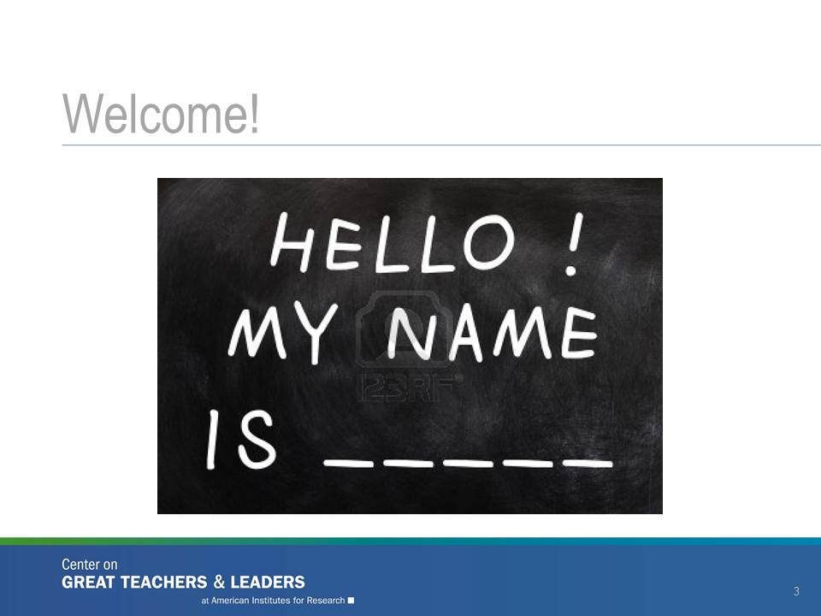  Slide 3
Slide 4 acknowledges that the Center on Great Teachers and Leaders authored the training content.  Explain:  “The training slides and materials for today’s session were developed by the Center on Great Teachers and Leaders, a national content center led by American Institutes for Research. The GTL Center is dedicated to fostering a network of policymakers, practitioners, researchers, and innovators into a system of support for states to ensure great teachers and leaders in all schools.”  The Great Lakes Comprehensive Center has collaborated with the GTL Center and ODE to support this facilitator training and to adapt these materials for use in Ohio. | Slide 4
Explain:  “The GTL Center is one of seven content centers that support the work of 15 regional centers. The blue column at the right shows all the content centers, such as the College and Career Readiness and Success Center and the Center on Standards and Assessment Implementation. The map shows the different regional centers that the content centers support. The Great Lakes Comprehensive Center is a collaborator in the design and facilitation of this training for Ohio.”  “All of these centers work collectively to support state education efforts.” | 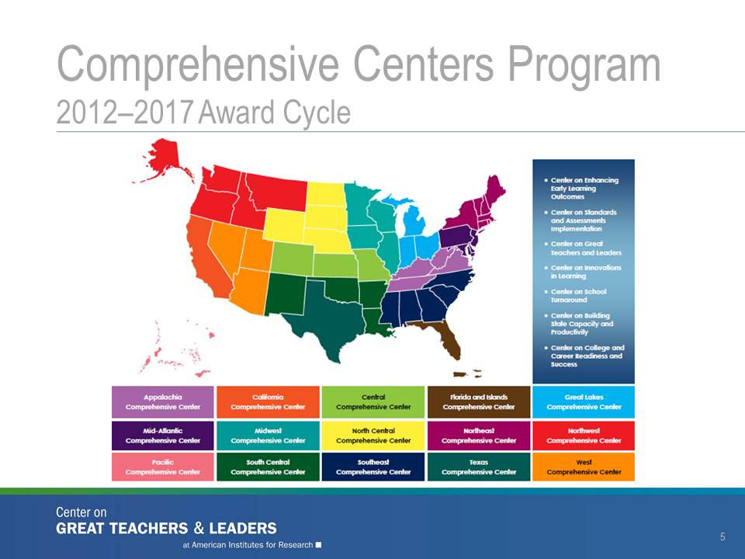  Slide 5
Explain:  “Today’s workshop provides resources and tools to support principals and district staff members in making decisions on the collection and use of teacher evaluation data for professional learning. We understand that much of the information presented today will not be new for most of you, but what we are hoping to do is to provide a framework for principals and district-level staff members to think through how to use teacher evaluation data to inform professional learning.”  “We will start by defining the big ideas and stating our assumptions so we’re all on the same page before we dig into this important work. We then will discuss the best way to use teacher evaluation data for different professional learning purposes and make meaning from the data. Finally, we will discuss school and district structures that can support a meaningful teacher evaluation and professional learning process.” | 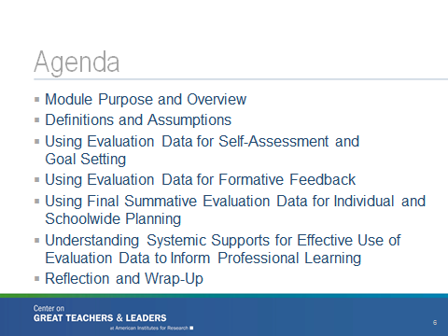Slide 6

Module Purpose and Overview (5 Minutes)
Explain:  “This Professional Learning Module is intended to support principals and district staff members as they consider how best to use teacher evaluation data to create and support a system of professional growth for teachers.”  “This module is one in a series of Professional Learning Modules developed by the GTL Center. Each module includes a slide presentation, an agenda, module activities, a facilitator’s guide, and additional resources. All of the materials in this Professional Learning Module are adapted to fit the needs of an Ohio context.” | Slide 7
Explain:  “During today’s session, participants will be able to:  Explain how teacher evaluation informs professional learning.  Practice analyzing different types of teacher evaluation data and use that analysis to make professional learning plans.  Discuss the challenges and opportunities for using evaluation data to inform professional learning.” | 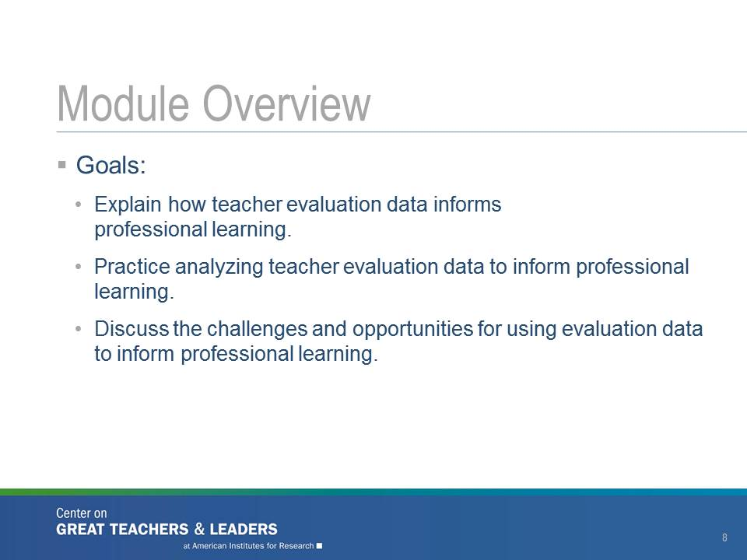  Slide 8
Explain:  “To start this module, we thought it would be helpful to provide a national picture of the number of states using evaluation data for professional learning. As you can see from this map, most states do not make an explicit connection between legislation, regulations, state code, board rule, or other legal documentation and the use of evaluation data in professional learning.”  “The 14 states highlighted in orange explicitly link the purpose of educator evaluations to professional learning, professional growth, feedback for improvement, or teacher support in state regulations.”  “The three states highlighted in yellow explicitly link the purpose of educator evaluations to improvements in teacher practice (but not professional growth) in state regulations.” | 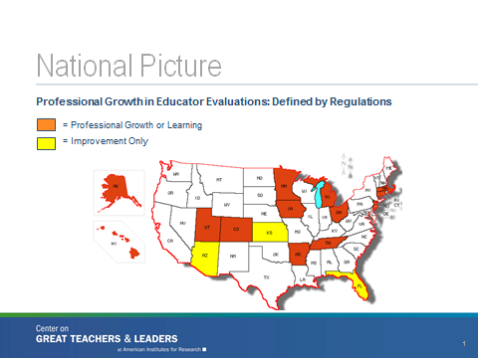  Slide 9
Explain:  “However, when you look at the national landscape on teacher evaluation and professional growth in a different way, you learn something very different.”  “The 36 states highlighted in green explicitly link the purpose of educator evaluations to professional learning, professional growth, feedback for improvement, or teacher support in state guidance documents or ESEA waivers.”  “The six states highlighted in blue explicitly link the purpose of educator evaluations to improvements in teacher practice (but not professional growth) in state guidance documents or ESEA waivers.”  “What you can take away from this second view of the states is that we’re all on the same page. That is, a key purpose of teacher evaluation is to encourage and support educators’ professional growth.” | 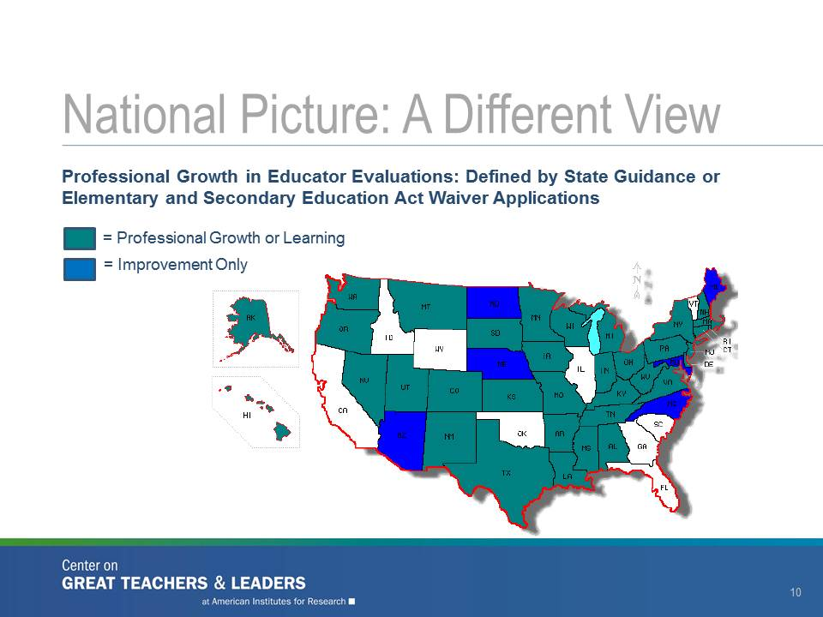  Slide 10

Definitions and Assumptions (60 Minutes)
Explain:  “Most of the reformed teacher evaluation systems are providing previously unavailable data to teachers, schools, districts, and states—data that help us figure out areas of strength and areas of improvement for educators. The national challenge ahead of us may be how to use these data not only to sort or classify teachers to make tenure or other kinds of decisions but also to identify ways to support teachers’ professional learning.”  “During our time together, we’ll examine ways to use data collected from the Ohio Teacher Evaluation System at the local level to design high-quality professional learning that is sustained and supported throughout subsequent evaluation cycles.”  “This module is built on some assumptions about data infrastructure and use as well as commonly used terminology such as professional learning and teacher evaluation. Let’s take some time now to create a shared understanding so that we’re all using the same words to mean the same things.” | 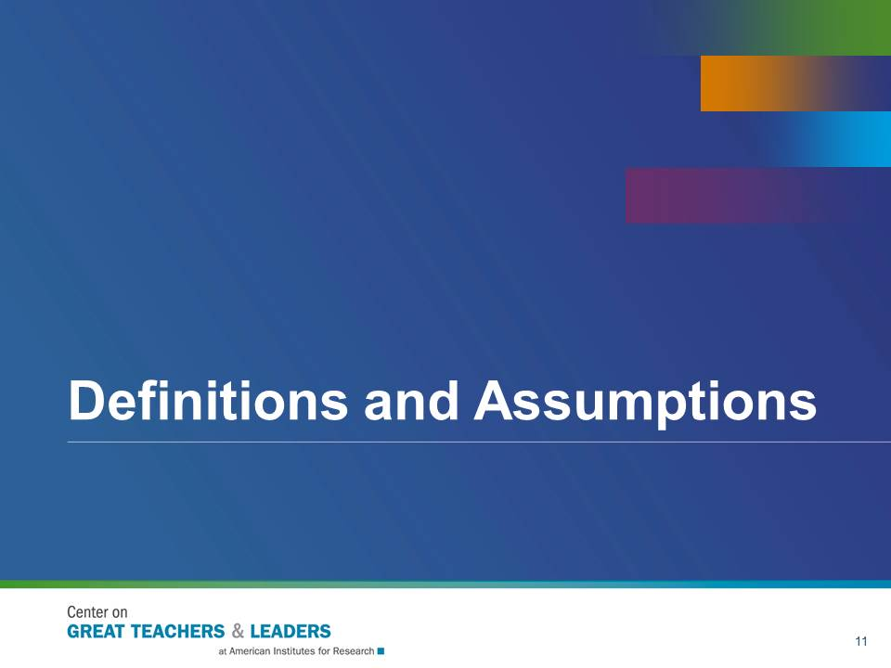  Slide 11
The purpose of Activity 1 is to get the participants thinking about their specific context. This activity also helps break the ice as participants share common experiences.  Explain:  “We would like to do an activity to get a better sense of how your district is using the Ohio Teacher Evaluation System—specifically where OTES has strong connections to professional learning. On one side of the room you’ll see a piece of chart paper labeled Strongly Agree and, on the other end, Strongly Disagree.”  “I am going to read three statements and will ask you to think about how they apply to your district. After each statement, pause for a moment to consider your district’s current situation. Then we’re going to create a human continuum based on your responses to those three questions—where you think your district falls. Afterward, you will share your thoughts with someone next to you.”  “Listen to the statements.”  “The first statement is: Our teacher evaluation system is able to identify areas for improvement for individual teachers.”  Ask participants to move toward the side of the room with the chart that best expresses their district’s situation. Next, allow two or three minutes for participants to talk with another person in that group and explain why they chose that position. Then conduct a whole-group share-out.  “The second statement is: Our teacher evaluation system connects teachers with relevant professional learning opportunities.”  Again, ask participants to move, share thoughts, and participate in a whole-group share-out.  “The last statement is: Our teacher evaluation system is able to identify highly effective teachers and can be used to determine career pathways, including opportunities as mentor teachers or lead teachers.”  Once again, ask participants to move, share thoughts, and participate in a whole-group share-out. Then ask them to return to their seats.  Wrap up the activity and transition to the next slide:  “From this activity, I saw or heard [summarize here]. Let’s keep these ideas in mind as we explore the many kinds of teacher evaluation data and their uses.” | 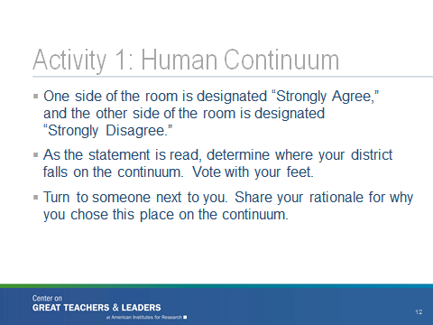  Slide 12
The purpose of Activity 2 is to for participants to come to a shared understanding of what professional learning means.  Explain:  “We’ll be talking about different types of professional learning throughout the session today. To make sure we’re all on the same page about our definitions of professional learning, take two or three minutes and list all of the professional learning activities that teachers engage in throughout the year. It might be helpful to think about the different venues in which professional learning can take place as well as the design and modes of delivery teacher’s experience. You can jot down your responses on the chart paper at your table.”  You may wish to demonstrate what you want participants to do. Be sure to circulate throughout the room while the groups are brainstorming.  “We’ll come back to these ideas in just a few minutes after we explore our definition of professional learning.” | 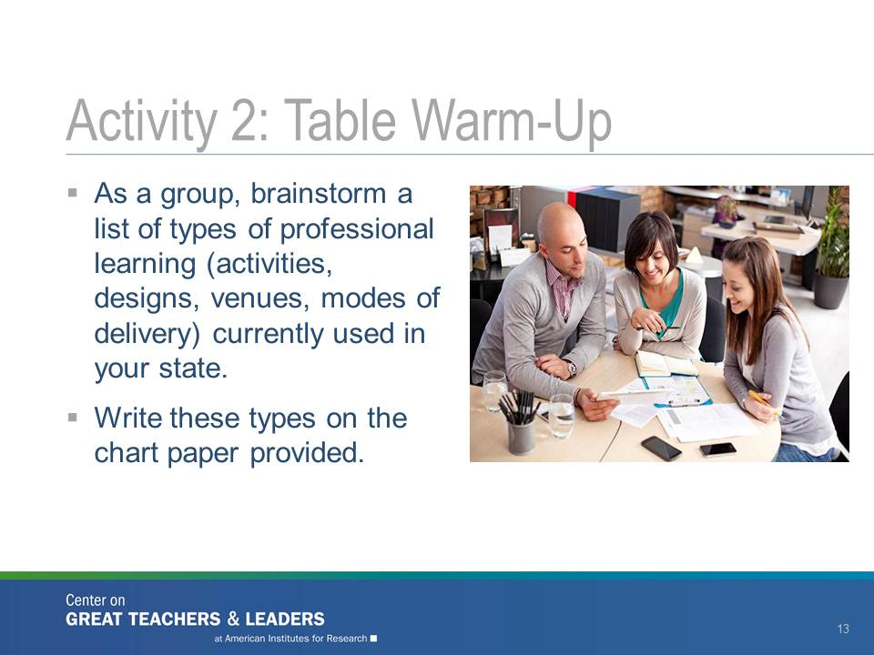  Slide 13
You might want to make a chart of this graphic so it’s easily referred to throughout the training.  Explain:  “In your table groups, I heard you talking about professional learning in terms of professional development opportunities (‘sit and get’), getting feedback from colleagues, and even setting professional goals. And while you probably discussed some of the not-so-great professional learning you’ve participated in, I also heard you discussing effective professional learning.”  “In 2011, the National Comprehensive Center for Teacher Quality published a brief titled High-Quality Professional Development for All Teachers: Effectively Allocating Resources. In this brief, professional development is characterized in five ways: aligned (with goals, standards, assessments, and other professional learning activities); focused on core content and teaching strategies; active; collaborative; and embedded.”  The brief is available online at http://www.gtlcenter.org/sites/default/files/docs/HighQualityProfessionalDevelopment.pdf.  “We’ve adapted that approach here and have identified three distinct categories (focused, active, collaborative) and three overlapping characteristics (ongoing, embedded, differentiated) of effective professional learning.”  As you talk through the definitions of these words, connect a few examples listed on the chart papers (from Activity 2: Table Warm-Up) with these big ideas.  “Focused. Professional learning activities that are focused on the content to be taught as well as effective teaching strategies for teaching content. Aligning professional learning activities with data analysis, goal setting, implementation strategies, and monitoring and evaluating improvement can be highly beneficial to administrators, teachers, and students.”  “Active. Research has shown that teachers report greater changes in their instructional practice as a result of professional learning activities that involve their active participation and engagement (e.g., practicing what they learned in their classrooms; observing other teachers; conducting demonstration lessons; leading group discussions; and reviewing student work with colleagues, professional development providers, or both).”  “Collaborative. Another feature of high-quality professional development is a learning strategy that teachers commonly employ with their students: group learning. As the authors of the State Policy Implications of the Model Core Teaching Standards (developed by the Interstate Teacher Assessment and Support Consortium) have stated, ‘Teachers develop expertise not as isolated individuals but through job-embedded professional development, and as members of collaborative, interdisciplinary teams with common goals for student learning.’ ”  This document is available online at http://www.ccsso.org/Documents/2010/State_Policy_Implications_Model_Core_Teaching_DRAFT_DISCUSSION_DOCUMENT_2010.pdf  “Last, we want to make sure that professional learning is ongoing, job-embedded, and differentiated. Ongoing professional learning carries the idea that learning is a continuous process and educators need time and space in which to learn. Providing regular opportunities for learning can increase the frequency with which educators try new things and take risks. Job-embedded professional learning is integrated into the workday and centered on actual problems of practice. Individualized professional learning for adults is a lot like differentiating learning for students. For some adults, observing teacher practice is more powerful than reading the research or description. Some adults will require more coaching and specific feedback than others.”  “If you would like more information about professional learning, you can visit the GTL Center website (http://www.gtlcenter.org) and find several resources on the topic of professional learning.”  “Now, let’s go back to the list of professional learning activities that your table groups generated. You may have guessed what we’re going to do on the right side of the chart.” | 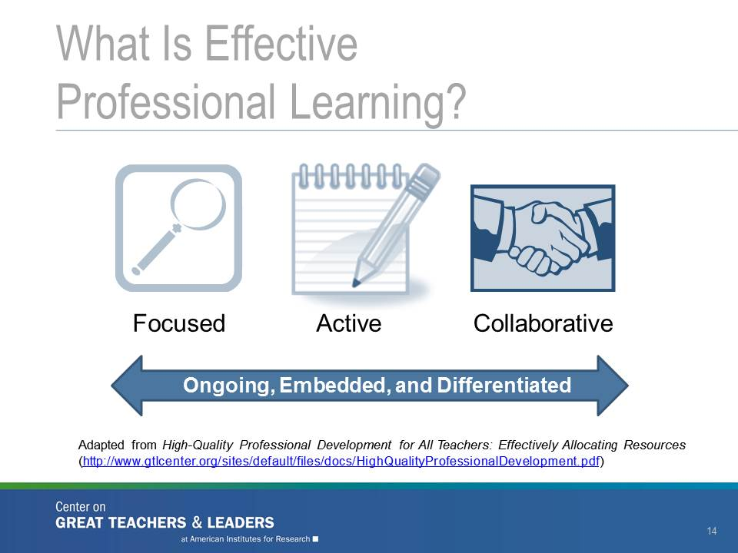  Slide 14
The purpose of Activity 3 is for participants to identify the professional learning activities that meet the definition of high-quality learning based on the features we have described.  Explain:  “As a table group, review the list of professional learning activities you developed for Activity 2. Using the definitions of effective professional learning just discussed, take five minutes to determine which features of effective professional learning apply to each activity you listed. Note whether each activity is focused (on content and teaching); involves active, applied learning by teachers; and involves collaborative engagement between teachers and colleagues or teachers and coaches.”  “If you get done early, go back and circle any activities that are differentiated by teacher needs (perhaps applicable to only some teachers); underline any activities that are ongoing through the year; and star (*) any activities that are job-embedded and integrated into a teacher’s day.”  After five minutes, have groups post their charts. Have a two-minute share-out to identify any trends or patterns that emerged in the table groups or across the whole group. | 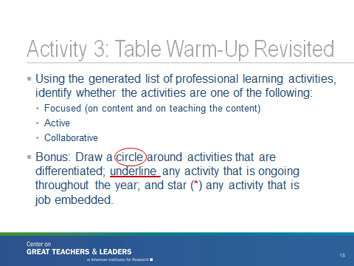  Slide 15
Explain:  “This slide highlights the cycle of evaluation data use. Across the country, states and districts have developed similar evaluation cycles that include the three steps in this cycle. The language and breakdown of steps may be slightly different (perhaps with a four-, five-, or six-step cycle), but these are the basic ‘buckets’ of a developmental evaluation cycle.”  “Self-assessment and goal setting includes:  Self-assessment/reflection  Teacher-led goal setting”  Teacher professional growth planning  “Formative evaluation includes:  Evidence gathering  Collaborative conversations and feedback  Reflection and adjustment”  “Final Summative evaluation includes:  Teacher performance rating based on evidence  Student academic growth rating” | 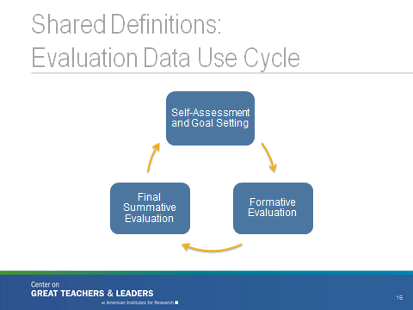 Slide 16

“Connecting each of these steps is an orange arrow. This arrow indicates the step where teachers and evaluators are gathering and analyzing evidence. Such evidence includes:
Observations based on a Teacher Performance Evaluation Rubric (formal and informal/ walkthrough observations)
Pre-Observation Conferences
Post-Observation Conferences
Mid-Year Review and Conference (not required, but recommended)”
Ask:
“Is there anything that’s part of your evaluation cycle or process that I didn’t mention? Where would it fit in this cycle? Is there anything you think doesn’t fit?”
Explain:  “We’ll be using the terms data and evidence interchangeably throughout this session. As we did with professional learning, we want to develop a shared understanding of what we mean by teacher evaluation data before we dig into how to use it to inform professional learning.”  “Evaluation data provide evidence of individual teacher practice and performance collected throughout the evaluation cycle.”  “Evaluation data can be quantitative or qualitative.”  “Evaluation data can provide information on teacher behaviors as well as student learning.”  “Evaluation data also can be aggregated to the school or district level.”  “Many states talk about summative evaluation ratings, but it is important to think more broadly than performance levels or ratings if we want to connect these data to professional learning. Lots of evidence is gathered throughout the year during the teacher evaluation process which should inform the final summative evaluation at the end of the year.” | 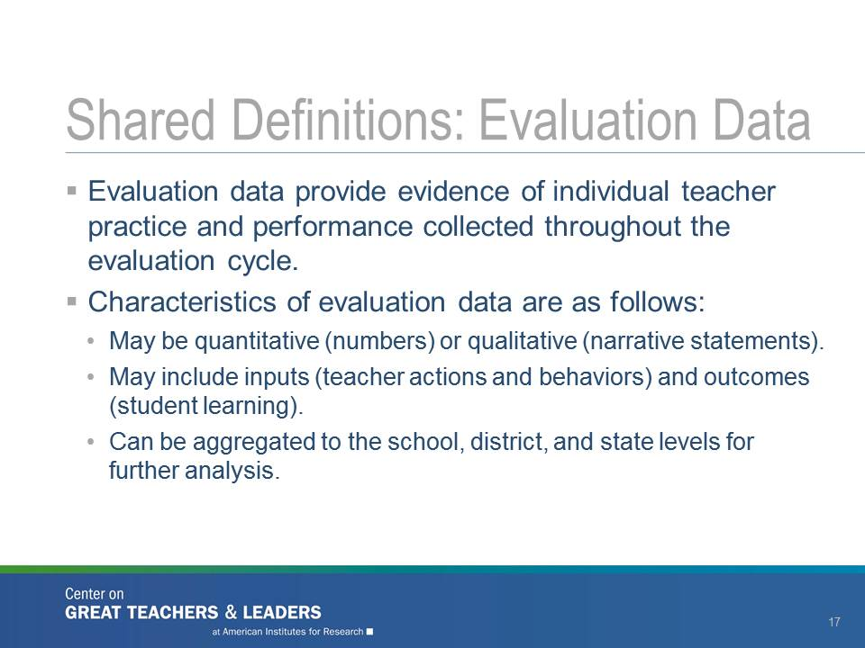  Slide 17
Explain:  “Evaluation data can mean different things to different people. Usually people think of evaluation data as those summary practice ratings of Ineffective, Developing, Skilled, or Accomplished, or student growth data linked to teachers, such as Value-Added measure scores. Sometimes data can mean the evidence or data elements that go into a final summative rating. Sometimes, when people use the word data, they really mean data sources, like evidence or observations.”  “In this workshop, let’s try to be specific when we talk about data and generally try to stick to the examples in the last two columns shown in this chart.”  Ask:  “As you study this chart, are there data elements or other summary data points that could be used to inform professional learning but are not listed here? I will give you a minute or so to think about that. You can check with a neighbor if you’re not sure of your answer before sharing it with the larger group at your table.” | 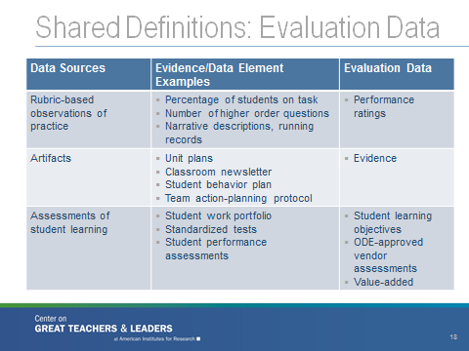  Slide 18
Explain:  “A teacher evaluation system focused on professional growth informs professional learning in three key ways: self-assessment, formative feedback, and professional growth planning.”  “Self-Assessment. Teacher practice evidence and student learning data gathered as part of the previous year’s teacher evaluation can be used as part of a needs assessment to identify areas for individual improvement and self-assessment and to inform decisions about individual goals and professional growth plans.”  “Formative Feedback. Evidence gathered throughout the evaluation cycle can be used formatively, translated into feedback for teachers about their practice. The advances in learning come when feedback is constructive, actionable, and connected to concrete strategies for improvement.”  “Professional Growth Planning. The final results of the teacher evaluation process—final summative ratings and evidence of student growth—can inform an individual teacher’s career opportunities and pathways as well as district-level plans for professional learning.”  “During the next hour, we will be discussing in more detail how to use evaluation data to inform each of these three activities. As we do that, think about the human continuum activity (Activity 1), where you were able to assess where OTES has strong connections to professional learning. As we dig into each of these steps in the evaluation cycle, think about which area is most critical for your school or district.” | 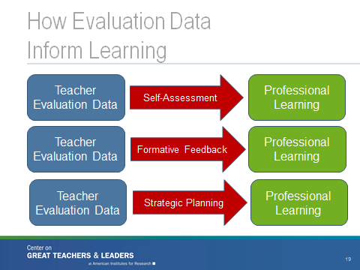  Slide 19

Using Evaluation Data for Self-Assessment and Goal Setting (30 Minutes)
Explain:  “We’ve spent some time developing a common language for professional learning and teacher evaluation and the connections between these critical pieces. Now, we’re going to get more concrete about how teacher evaluation data can inform meaningful, teacher-directed professional learning and growth.”  “Let’s start with the use of teacher evaluation data for self-assessment and professional growth planning.” | 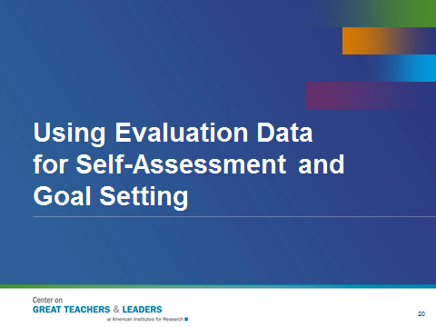  Slide 20
Explain:  “The Ohio Teacher Evaluation System provides teachers the opportunity to engage in a self-assessment activity and to set goals based on an assessment of strengths and areas of growth. This assessment is part of a professional growth plan. During the teacher self-assessment and goal-setting step in the evaluation data use cycle, teachers lead their professional growth by engaging in a series of tasks.”  “Just like students, educators who take charge of their own learning and professional growth are likely to make the most gains. Research suggests that teachers who analyze their practice on student learning, engage in self-assessment activities and modify practice accordingly, and collaborate with colleagues are likely to demonstrate increased professional growth.”  “First, the teacher analyzes student data. The teacher then engages in self-assessment on the impact of his or her practice on student learning. Using that information, the teacher then sets two priorities (goals) for professional growth: one focused on student achievement/ outcomes for students and one focused on teacher performance on the standards. The teacher collaborates with colleagues throughout the year to continue working toward meeting the goals. Throughout the year, the teacher also can make adjustments to the strategies, resources, or supports needed to meet those goals. This situation usually is not an opportunity to change the goals but rather an opportunity to make adjustments on how to meet the goals. This step addresses the key characteristics of high-quality professional learning; it is focused, active, and collaborative.”  Refer to one or two specifics from the earlier discussion. | 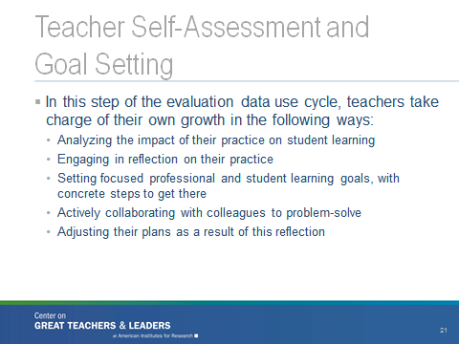  Slide 21
Read the slide.  “What teacher evaluation data will be most helpful to a teacher when engaging in self-assessment and goal setting?”  “Review the list of data gathered during the teacher evaluation cycle from slide 18.”  “What teacher evaluation data would be most valuable for self-assessment purposes?”  “What data are least useful?”  “Use Handout 1 to record your thoughts.” | 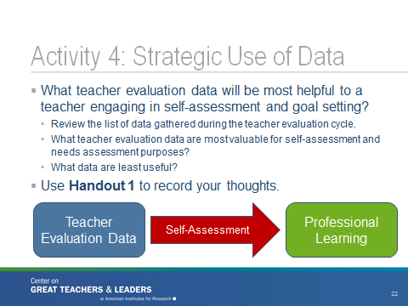  Slide 22
Explain:  “Next, I have a sample self-assessment for you to consider. We’re going to work to make the reflection stronger and link an assessment of strengths and areas of growth to a professional growth plan. Please look at Handout 2, which talks about Mr. Green’s self-assessment. As you read this handout, identify the data that Mr. Green used for his self-assessment. Which data seem to be least informative? Where would you suggest that Mr. Green dig deeper? Let’s take five minutes for you to talk as a table group and then we can come back and discuss as a whole group. What should be the two priorities for goal-setting and professional growth?”  After five minutes, pull the group together. Ask for table summaries of discussion around the data sub-bullets.  “Now, take eight minutes as a table group to brainstorm professional learning supports you would connect with Mr. Green if he were a teacher at your school.”  After eight minutes, ask:  “Who would like to share out what types of professional learning supports you identified for Mr. Green?”  Allow one or two participants to share out. | 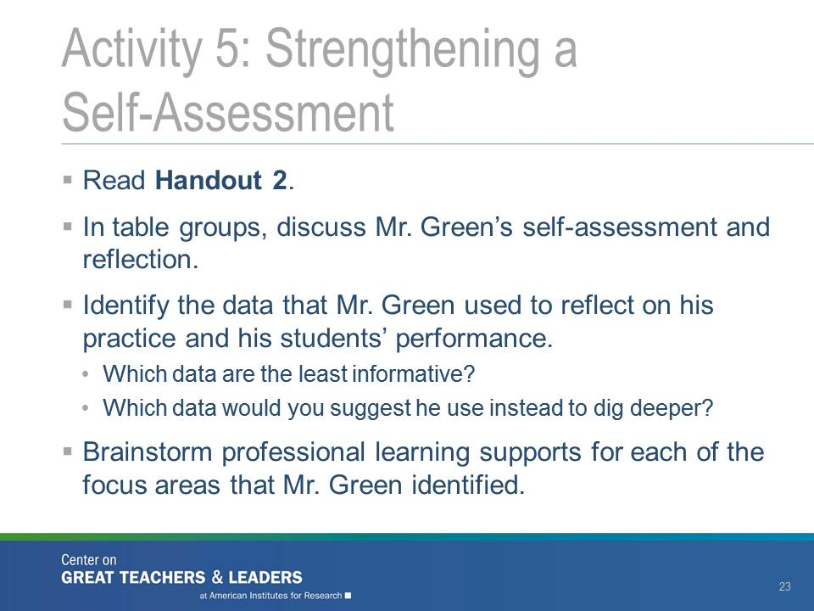  Slide 23

Using Evaluation Data for Formative Feedback (45 Minutes)
Explain:  “As we’ve already discussed, engaging in formative feedback and problem solving can be collaborative and active professional learning. Now, we want to think about which data are best suited to providing formative feedback. We also want to determine the features of feedback that are most tightly linked to professional learning and growth.” | 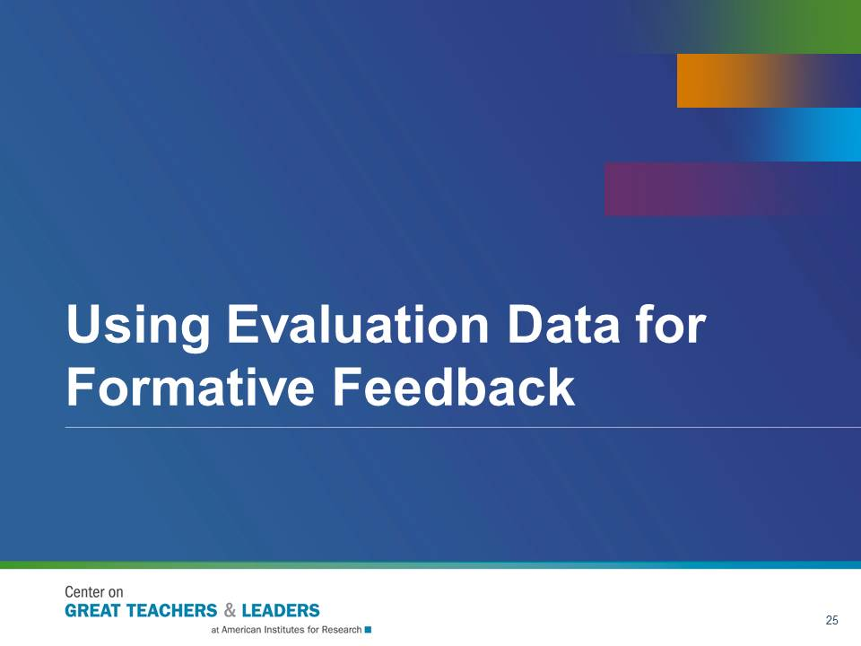  Slide 24
Explain:  “The formative evaluation step of the evaluation data use cycle is a critical learning opportunity for teachers and evaluators. The focus is on a review of the evidence (data) gathered to date.”  “The goals of formative evaluation are to provide authentic and specific feedback that is removed of any biases and grounded in evidence. The feedback should encourage teacher self-reflection and identify specific learning supports.”  “The activities that accompany formative evaluation include collaborative conversations between the teacher and the evaluator, adjustments to goals and plans, and connections to professional learning supports.” | 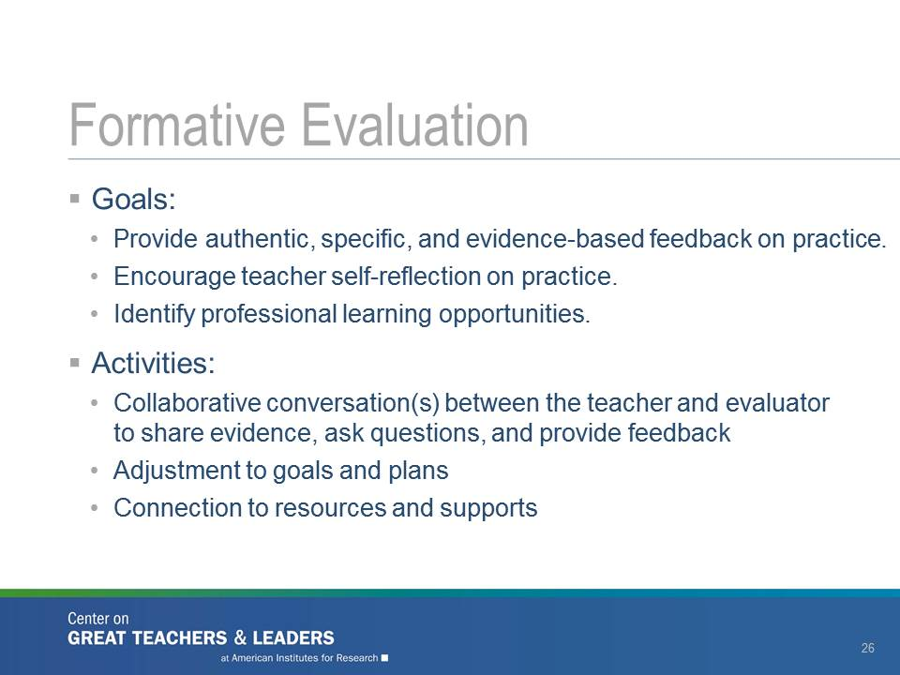  Slide 25
Explain:  “Formative evaluation occurs throughout the year and has the most impact when it’s shared soon after the data are gathered. But simply sharing the evidence or a write-up of performance is not sufficient to drive teachers’ learning. The missing link is constructive feedback, which can effectively diagnose areas for instructional improvement and link the teacher with strategies or next steps for improvement regardless of teacher rating.” | 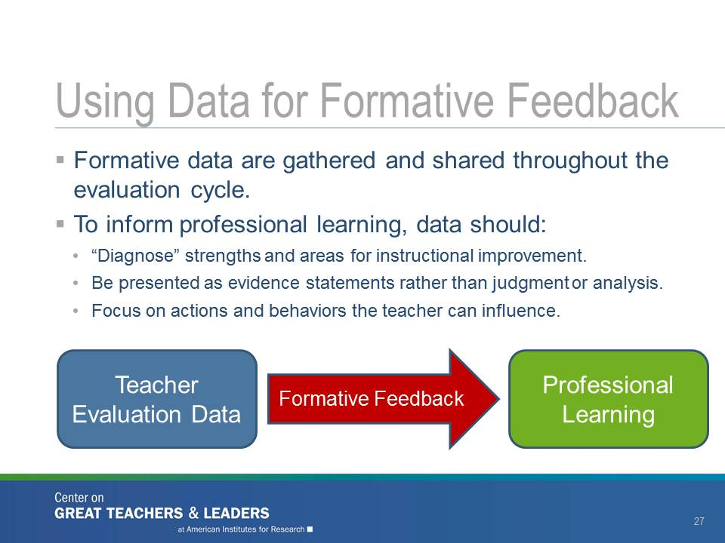  Slide 26
Explain:  “Evaluators can translate evidence (data) about teacher practice into actionable feedback to teachers. When delivered effectively, such feedback can generate productive conversations.”  “Providing feedback can sometimes be uncomfortable and difficult—especially if the feedback may be surprising to teachers or contrary to what’s previously been shared with them.”  “We’re going to talk through four practices of providing feedback that can help those conversations feel less threatening and more productive; creating a greater likelihood that professional learning will result.” | 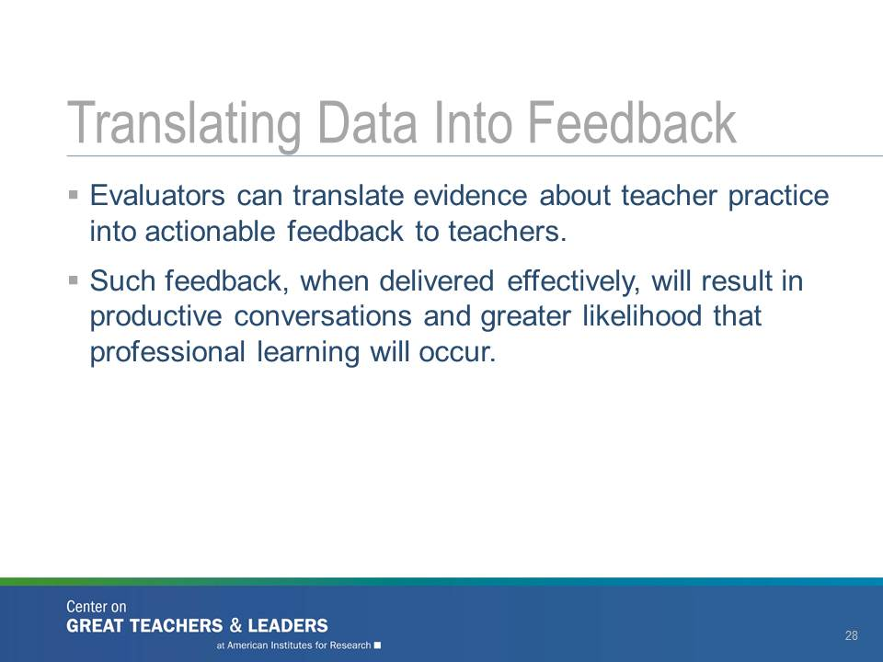  Slide 27
Explain:  “Turn to Handout 3, which illustrates the four characteristics of high-quality feedback. Each characteristic is divided into two boxes: one for Key Points and one for Video Notes. You will use this handout later while watching a video of a department chair providing feedback to a teacher.”  “But first, I’m going to provide some details about each of the characteristics of high-quality feedback. Feel free to jot down any Key Points on the handout while I’m sharing the information. After that, we’ll watch the feedback conversation and use the Video Notes boxes for that activity.” | 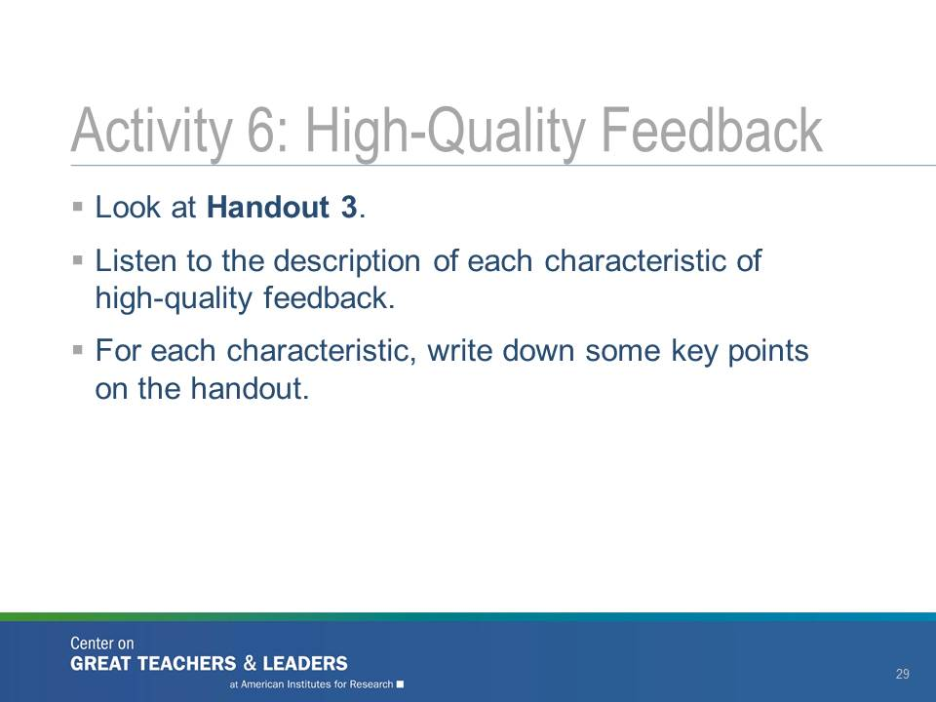  Slide 28
Explain:  “To help teachers improve their practice, regardless of the data and measures, effective feedback should be tied to specific teaching standards from the Ohio Standards for the Teaching Profession or the Ohio Teacher Evaluation System (OTES) rubric. The standards provide a common language as well as specific values and descriptions of what constitutes effective teaching.”  “Effective feedback should be specific and detailed. This is another area where the teaching standards can help guide evaluators to provide specific and detailed feedback. Feedback should focus on specific data and evidence. Evaluators must be able to demonstrate to teachers their areas of strength and weakness using data and evidence. Basing conversations on evidence collected will help reduce subjectivity and improve teachers’ ability to reflect on their practice. In addition, feedback should be evidence based feedback, which helps alleviate some of the emotions involved in the evaluation process. Referring back to the evidence collected can help facilitate and ease difficult conversations when discussing a teacher’s performance.”  “Effective feedback also should be timely and frequent to give teachers time to improve their instruction and implement various professional learning outcomes. The feedback will have less impact and be difficult for teachers to comprehend if they receive it long after the lesson occurred. The frequency of feedback supports monitoring of progress as teachers implement new strategies.”  “In most teacher evaluation systems, however, the opportunity for feedback occurs during post-observation conferences. During these conversations, an evaluator discusses what he or she saw during the observation and provides the teacher with strategies and suggestions on how to improve. These conversations are less meaningful if they occur months after the observation.”  “It also is important that feedback is constructive and question driven―and not just critical. If the feedback focuses on only a teacher’s weaknesses and there is no discussion of how he or she can improve these areas, then no professional learning will occur. It is essential for the evaluator to focus on areas of reinforcement as well as areas of refinement.”  “Now, take a minute and think about your school or district. Which of these practices are included in your teacher evaluation system? How? How do these feedback conversations support professional learning?” | 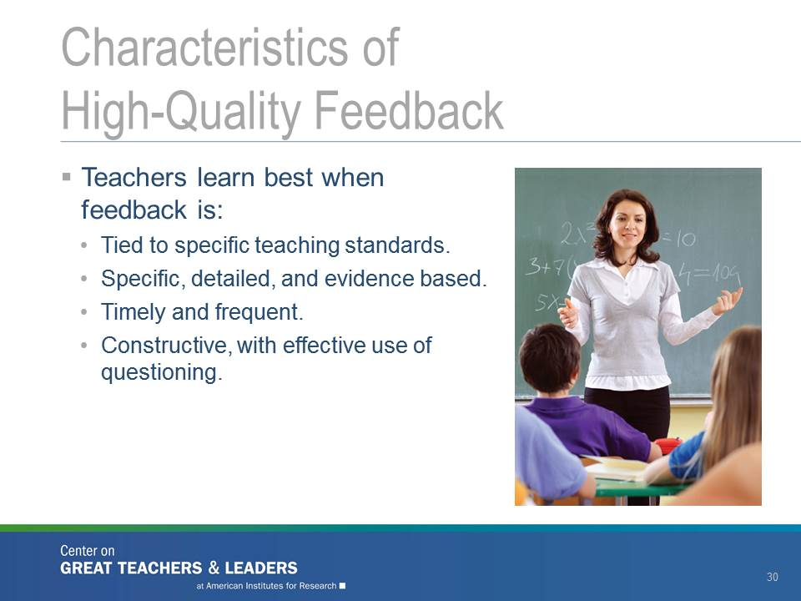  Slide 29
Explain:  “Next, we’re going to watch a five-minute video of a feedback session. Using Handout 3, jot down things you see or hear in the video that align with the high-quality feedback practices we just discussed.” | 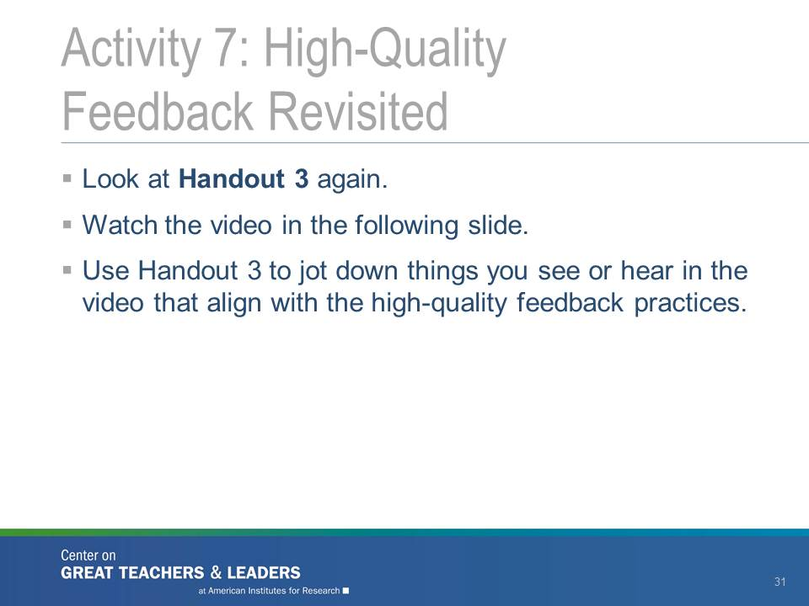  Slide 30
Set up the video by using the link and password indicated on the slide. Then show the video. Afterward, facilitate a discussion about what participants saw and heard, referring to the handout and talking points as much as possible.  Ask:  “To what extent did this feedback session promote learning?”  “What data or evidence did Ms. Viss refer to in her questions?”  Have participants discuss at tables and share responses. | Slide 31

Using Final Summative Evaluation Data for Individual and Schoolwide Planning (90 Minutes)
Explain:  “The third and final way we think about linking teacher evaluation and professional learning is perhaps the most obvious: by analyzing final summative (or end-of-year) evaluation data. But, as you’ll see, there is lots of room for interpretation even in this last step of the evaluation cycle.” | Slide 32
Explain:  “When thinking about final summative evaluation data, the data should be connected to an individual teacher and identify trends and patterns in teacher and student performance. This information also can be aggregated at the school level to identify trends among teachers and students in a school building. Like formative data, final summative data also should identify professional learning opportunities for teachers.”  “Some of the activities associated with summative evaluation data include determining a final, summative performance rating for the teacher based on evaluation data; having conversations between the teacher and their evaluators about the trends identified in the data; and connecting to specific professional learning resources.” | 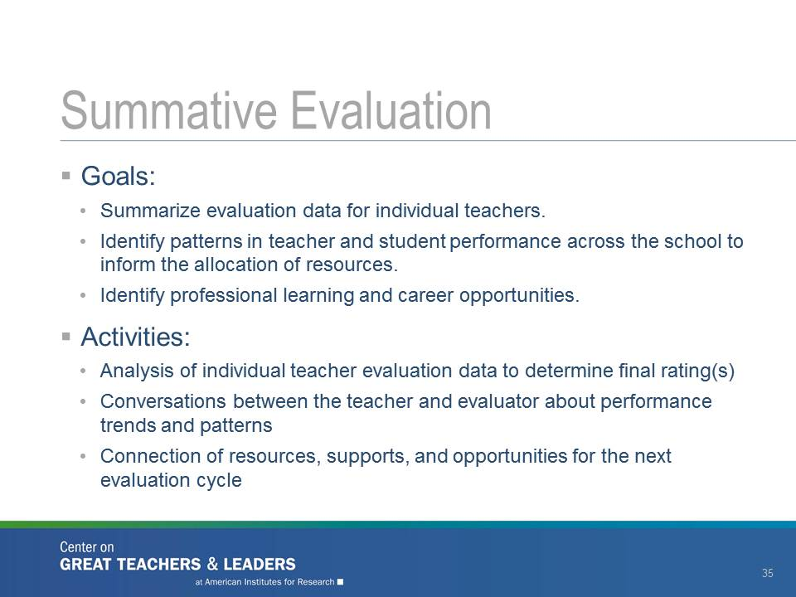  Slide 33
For Activity 8, you will use Handout 4: Ms. Blue, Eighth-Grade Mathematics Teacher—Making Sense of the Data. You also will need chart paper for each table group. Either put the chart paper on each table or hang it on the wall near each table.  Explain:  “Turn to Handout 4. You will find a scenario about Ms. Blue, an eighth-grade mathematics teacher. Read the scenario, and think about how you would use the data to co-develop a professional learning plan with Ms. Blue.”  “Work with your table group to agree on a plan, and write it on the chart paper provided. You should include Ms. Blue’s learning goals (one or two key goals), some learning activities she should participate in to make sure she meets those goals, and one or two success metrics (measurements of how you would know she has met her goals).”  Write on chart paper to demonstrate the expectations for this activity:  Ms. Blue’s Professional Learning Plan  Learning Goals  Learning Activities  Success Metrics  Facilitators should be ready to answer questions about the data in the activity. For example, some participants may ask how reliable the observation data are. You might respond “as reliable as the data that are currently gathered in your state or district.” Let participants struggle with making decisions based on data that may not be 100 percent reliable.  Facilitate a whole-group share-out of the professional learning plans developed by the participants. You may have each group discuss their identified goal(s) and why they chose the goal(s) first, then have them share their activities and success metrics in succession and point out common themes. Or you may want to have each group share its plan for the whole group and again summarize with common themes after each group is done describing its plans. | 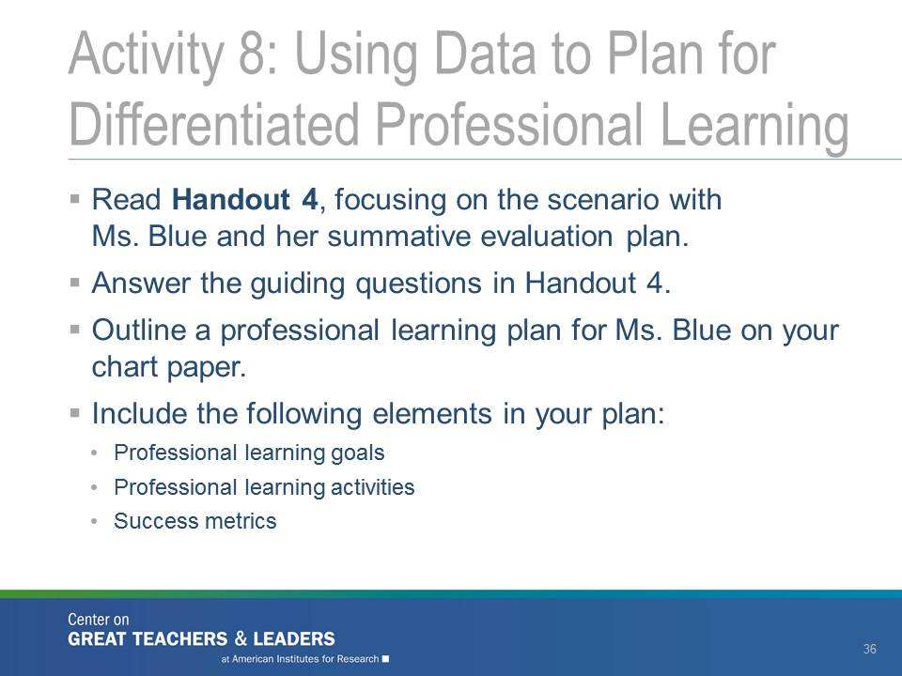  Slide 34
Activity 9 uses Handout 5: Orange School―Making Sense of School-Level Data.  Explain:  “Now we have some data from Ms. Blue’s school, the Orange School. Ms. Blue’s administrator identified two standard areas to review in detail (Std.2-curriculum; Std.4-assessment) as these were the areas many of his teachers identified in their goals for their professional growth plans.  Take a few minutes to review these data, and share with the group some of the patterns you see. With your group, discuss the answers to the questions in the slide.”  Have participants “popcorn out” some of their observations about the data and indicate what schoolwide decisions they may make.  Participants likely will notice that some teachers are rated as accomplished or skilled on their performance (observation) ratings but have low student achievement outcomes. You may want to flip to the next slide as you discuss this observation. | Slide 35
Explain:  “Sometimes the data on teacher practice conflicts with student growth data. So, what could you do in that case?”  Ask each question in succession (the slide is animated).  “Could you (A) collect more data to better understand the discrepancy?”  “Could you (B) consider the data source—that is, determine whether the raters were reliable? Were the achievement tests used to measure student growth high-quality instruments assessing student understanding of the taught curriculum?”  “Could you (C) dig deeper into the data to make sure that the instrument was measuring what it was intended to measure? Do the constructs overlap?”  “Could you (D) offer professional learning in an area that teachers may or may not actually need―just to be on the safe side?”  (F) Other  Facilitate a whole-group discussion of the described options. | 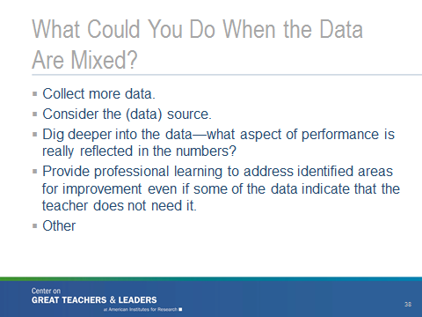  Slide 36
Explain:  “We tried our hand at using some mock summative data to develop individual professional learning plans and make schoolwide professional development decisions.”  “Take a few minutes in your table groups to discuss the guiding questions on the slide.”  After five minutes, ask for a few people to share out any  “ahas!” | 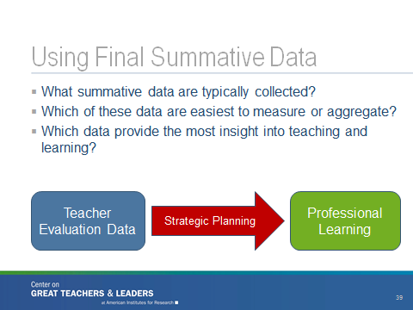  Slide 37
Explain:  “Now that we have had a chance to discuss effective planning for professional learning using evaluation data, this slide details some of the principles you should consider following.” | 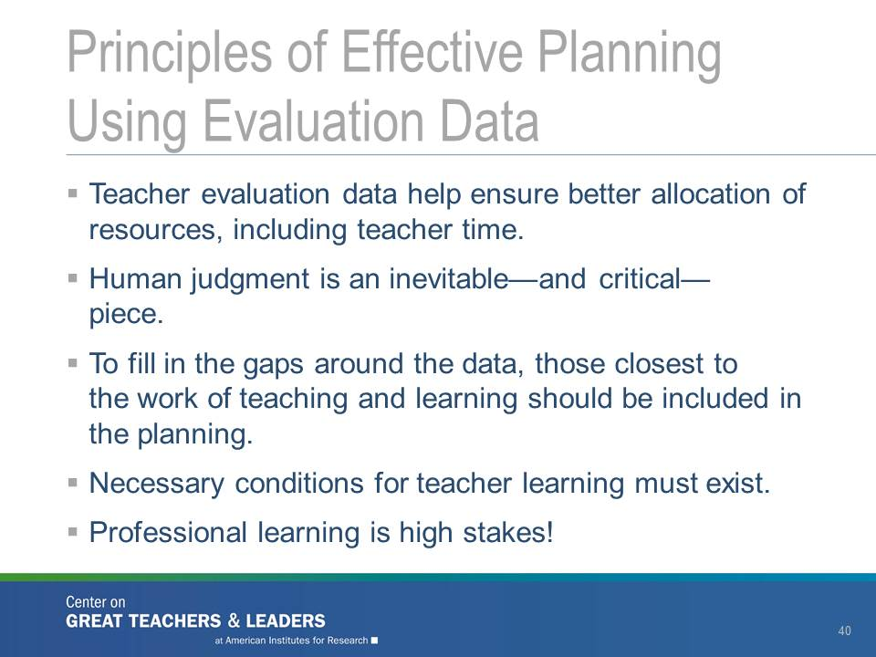  Slide 38
Explain:  “Now that we have provided an overview of the PLM and the facilitated activities, let’s think about the conditions that are essential to using evaluation data to provide focused and ongoing professional learning as described throughout the module. | 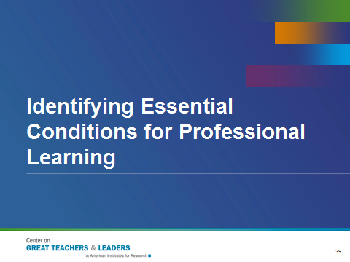 Slide 39
Use chart paper that identifies four categories of conditions: structural, cultural, technical, and fiscal.  Explain:  “As you see on this slide, there are four conditions, structural, cultural, technical and fiscal that will foster the success of using evaluation data in the manner described throughout the module. For example, even though we know that the best type of professional learning is focused, job-embedded and ongoing often districts are in the mode of having “professional development days” which rarely lead to increased teacher capacity and changes in instruction. Conditions need to be established to ensure that high-quality professional learning is implemented and sustained.” | 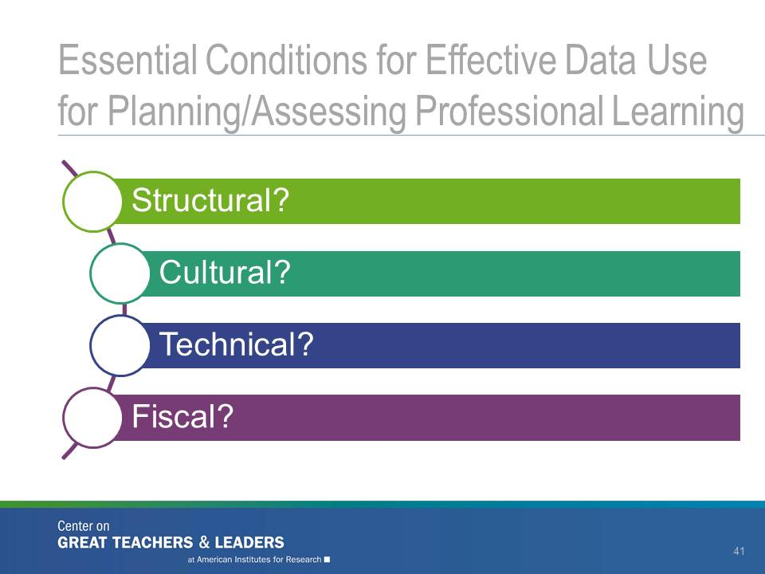  Slide 40
Explain:  “When we talk about structural conditions, we are referring to the policies, programs, practices and structures that need to be in place. Cultural refers to the necessary change in climate or attitude, including changes in culture, to be successful. Technical identifies the technical aspects such as the skills, expertise, and content knowledge necessary to get the work done. Finally, fiscal relates to the financial supports needed to do this work.” | 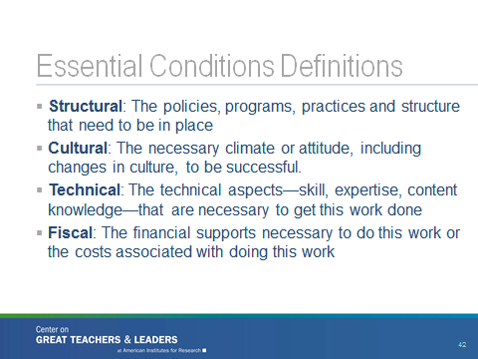Slide 41
Explain:  “In this next activity, I would like you to select one Essential Condition [structural, cultural, technical or fiscal] per person. Then, using the Post-It notes on your table, list a challenge or condition that has to be in place to ensure effective professional learning is provided to all teachers. For example, if one person chooses Cultural, a challenge could be that you’re your district does not have a sense of trust between teachers and evaluators. This could also be phrased as a condition where teachers and evaluators need to have a climate of trust to have fruitful feedback conversations. Feel free to create as many Post-It notes as you can for your Essential Condition topic. Discuss the challenges and identify the essential conditions needed in your districts to address those challenges.”  Do a large group share-out once table teams have had time to talk with each other. Also, you may want to put Slide 41 up when doing this activity so participants have the definitions in front of them. | 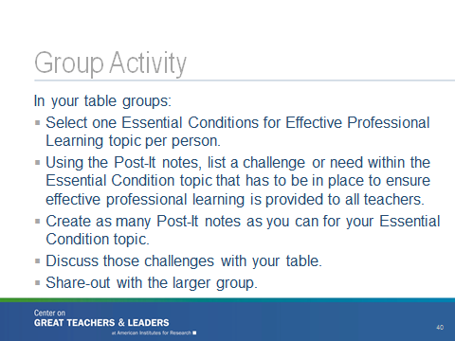Slide 42

Understanding Systemic Supports for Effective Use of Evaluation Data to Inform Professional Learning (60 Minutes)
Explain:  “In addition to the three-step cycle of data use, it’s important to understand how systemic supports for effective use of evaluation data can promote professional learning.” | 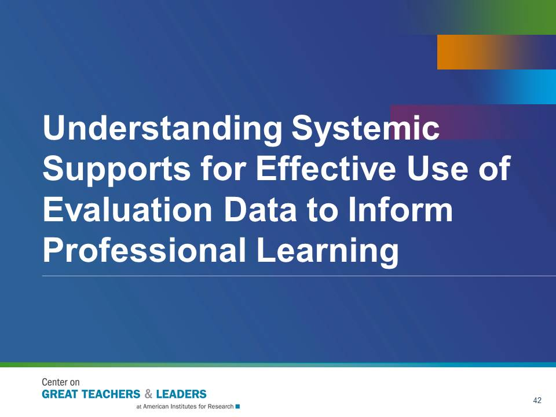  Slide 43
For Activity 10, use Handout 6: Promising Examples of Systems That Are Creating the Conditions for Using Data to Inform Professional Learning.  Explain:  “Handout 6 describes four examples of innovative ways that districts across the country have created the fiscal, technical, cultural, and structural conditions necessary to ensure that evaluation data can be used effectively to support professional learning.”  In each group, facilitate a jigsaw activity, where one person in each group reads one of the examples in the handout. That person then will present that example to the rest of the group stating why it’s a good example (or not) of the kinds of things that need to be done to support professional learning.  After everyone has presented and the groups discuss the pros and cons of each example, they should vote on which one they will study further to see if it can be applied in their context.  The facilitator should then tally the votes and sum up the discussion. | 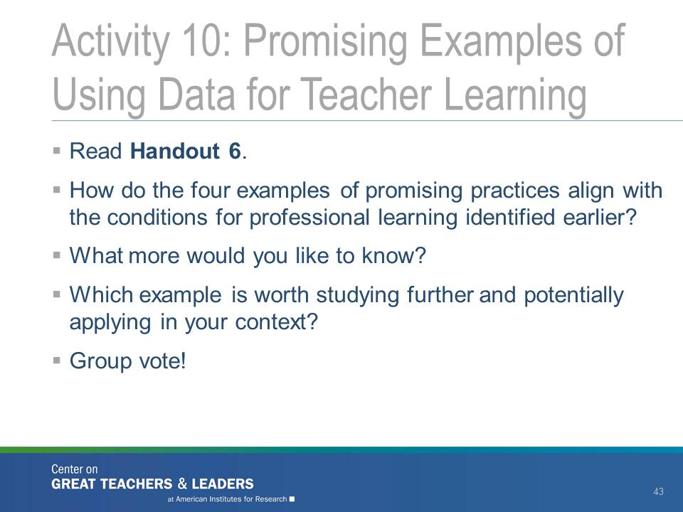  Slide 44
For Activity 11, use Handout 7: District Professional Learning Self-Assessment.  Use this slide and Handout 7 ONLY if district teams are the main participants in the workshop.  Direct teams to Handout 7 (the district self-assessment tool). Give them 10 minutes to review and reflect on their district’s professional learning systems and supports. | 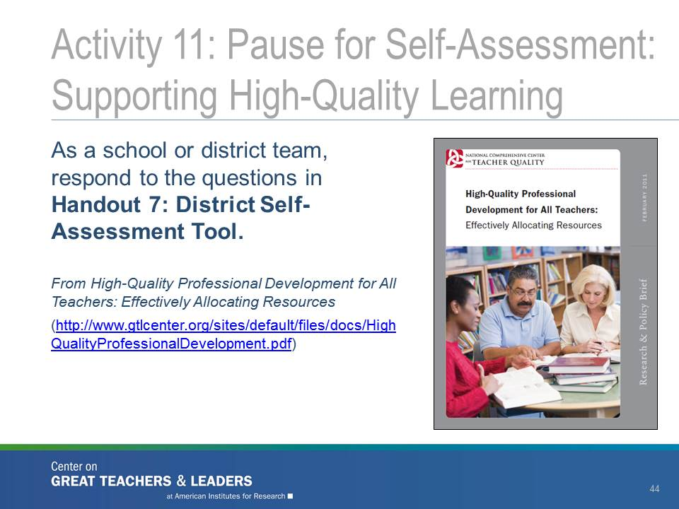  Slide 45
Explain:  “Now let’s take what we have learned to begin some initial action planning. Work with 1-2 other people to address the questions in Handout 8: District Action Plan. The purpose of this activity is to begin thinking about next steps for your district in designing professional learning.” We may ask for one or two volunteers to share their initial planning effort.” | 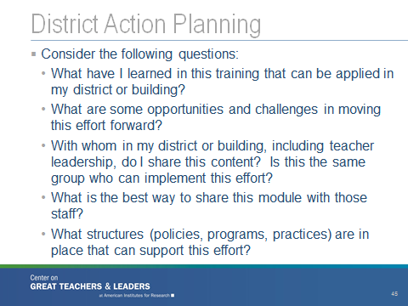  Slide 46

Reflection and Wrap-Up (15 minutes)
This section of the workshop provides an opportunity for participants to reflect on what they learned and to consider ideas and strategies to take back with them. | Slide 47
Explain:  “As discussed throughout the session today, we want to summarize that high-quality professional learning has a set of research-based characteristics: It should be focused, active, and collaborative. First, professional learning that focuses on the content to be taught and emphasizes how to teach the content is more effective than professional learning focused on general strategies. Next, research also shows that teachers report greater changes in their instructional practice through active professional learning activities. Finally, a key feature of high-quality professional development is collaborative opportunities for group learning.”  “In addition to these characteristics, we want to make sure that professional learning is ongoing, job-embedded, and differentiated.” | 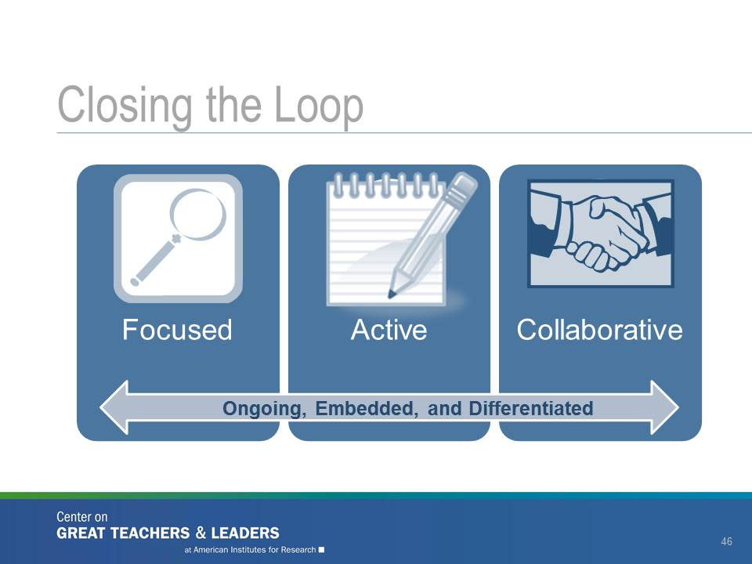  Slide 48
Explain:  “We’d like to close today with a few final thoughts about the shifts we’re trying to make, from teacher evaluation to teacher evaluation and support. Read through these shifts individually and then turn to an elbow partner and either expand upon these, or generate additional shifts, or both. We will select a few volunteers to share their ideas with the group.” | 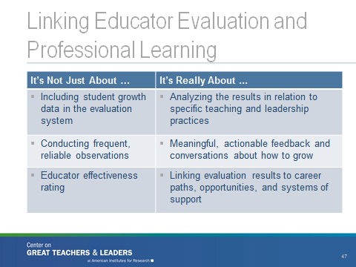  Slide 49
Explain:  “To support some of this work, we’ve provided some additional resources that may be helpful as you think about using teacher evaluation data to inform professional learning.” | 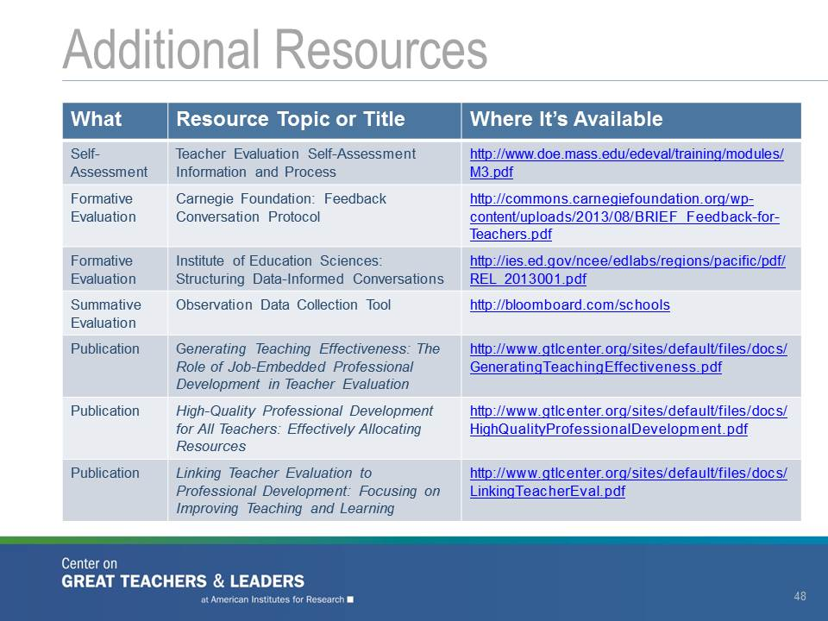  Slide 50
Explain:  “Thank you for your time today. Please contact the Ohio Department of Education, Center for the Teaching Profession with any questions. To access these materials online or to browse other resources to support great teachers and leaders, please visit the GTL website. The mission of the GTL Center is to advance state efforts to grow, respect, and retain great teachers and leaders for all students. We look forward to working with Ohio in this partnership!” | Slide 51

About the Center on Great Teachers and Leaders

The Center on Great Teachers and Leaders (GTL Center) was created to help states leverage their strengths to improve the educational attainment of all students by ensuring an effective teacher in every classroom and an effective leader in every school. Funded by the U.S. Department of Education, the GTL Center is part of the U.S. Department of Education’s Comprehensive Centers program, which includes seven content centers that focus on specific areas of expertise and 15 regional centers that provide services primarily to state education agencies to enable them to assist districts and schools.

In its role as a content center, the GTL Center is responsible for providing in-depth knowledge, expertise, and analyses to regional centers and the states they serve. The GTL Center disseminates information about scientifically based research on effective practice, creates research-based products, and provides expertise that regional centers can use in delivering technical assistance to states.

