About This Booklet
This Using Teacher Evaluation Data to Inform Professional Learning: Handouts booklet is intended for use with the following additional resources:
- Using Teacher Evaluation Data to Inform Professional Learning: Facilitator’s Guide
- Sample agenda
- Slide presentation
These online resources are available for download on the Professional Learning Modules webpage of the Center on Great Teachers and Leaders website. Please visit the webpage at http://www.gtlcenter.org/technical-assistance/professional-learning-modules/.
Adapting This Booklet
This booklet is designed so that facilitators can adopt it as written or modify the content to
reflect state and local context, needs, and priorities. If modifications to content are made, the GTL Center requests that the following disclaimer be included in the revised materials:
This booklet was modified in whole or in part with permission from the Center on Great Teachers and Leaders.
Contents
Page
Handout 1: Teacher Evaluation Data Placemat 1
Handout 2: Mr. Green, Fourth-Grade Teacher—Self-Assessment and Reflection 2
Handout 3: High-Quality Feedback Note-Taking Guide 7
Handout 4: Ms. Blue, Eighth-Grade Mathematics Teacher—Making Sense of the Data 8
Handout 5: Orange School―Making Sense of School-Level Data 10
Handout 6: Promising Examples of Systems That Are Creating the Conditions for Using Data to Inform Professional Learning 11
Handout 7: District Professional Learning Self-Assessment 13
Handout 8: District Action Plan………………………………………………………………………………………………..14

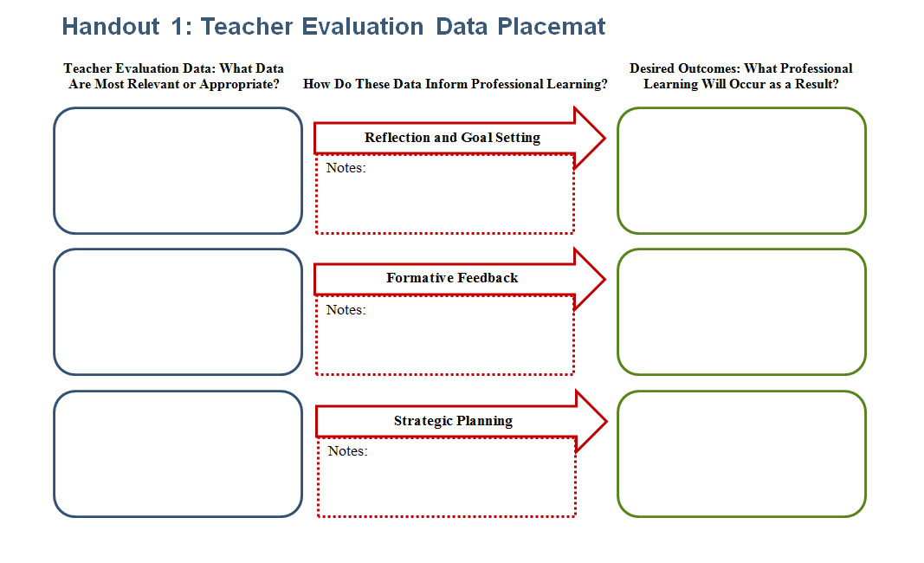
Ohio Teacher Evaluation System | Self-Assessment

Handout 2: Mr. Green, Fourth-Grade Teacher—Self-Assessment and Reflection
Self-Assessment Summary Tool
Name

Date
Directions: Teachers should record evidence to indicate strengths and areas for growth for each standard.
Then, look across all of the standards holistically and identify two priorities for the upcoming year.
Note these two priorities with check marks in the far-right column.

Standard |  | Strengths | Areas for Growth | Priorities (Check 2)
Standard 1: Students | - Knowledge of how students learn and of student development  - Understanding of what students know and are able to do  - High expectations for all students  - Respect for all students  - Identification, instruction and intervention for special populations | - Review student achievement data with third grade teachers before year begins.  - Meet with students to develop reading goals for the quarter.  - Develop rigorous lessons based on student skill levels and cultural experiences. | - Work on problem-solving and critical thinking skills. | ☐
Standard 2: Content | - Knowledge of content  - Use of content- specific instructional strategies to teach concepts and skills  - Knowledge of school and district curriculum priorities and Ohio’s New Learning Standards  - Relationship of knowledge within the discipline to other content areas  - Connection of content to life experiences and career opportunities | - Design instructional units in mathematics that integrate Ohio’s New Learning Standards with district curriculum.  - Develop center groups to provide enrichment and remediation for students in math based on assessment results. | - Seek professional development to learn strategies for differentiation in math. | ☐
Standard 3: Assessment | - Knowledge of assessment types  - Use of varied diagnostic, formative and summative assessments  - Analysis of data to monitor student progress and to plan, differentiate, and modify instruction  - Communication of results  - Inclusion of student self-assessment and goal-setting | - Use diagnostic reading assessments (at multiple points in the year) and analyze data to guide my instruction in the classroom. | - Need to learn strategies on how to differentiate reading instruction and intervention based on individual student data.  - Develop a communication plan for parents.  - Develop tools for students to self-assess their reading skills. | ☒
Standard 4:  Instruction | - Alignment to school and district priorities and Ohio academic content standards  - Use of student information to plan and deliver instruction  - Communication of clear learning goals  - Application of knowledge of how students learn to instructional design and delivery  - Differentiation of instruction to support learning needs of all students  - Use of activities to promote independence and problem-solving  - Use of varied resources to support learner needs | - Use a self-monitoring system for students in mathematics. Students track their own progress for each math unit and set goals at beginning of unit, and reflect at end of unit.  - Alignment to Common Core Standards in Math.  - Use varied resources to support learner needs. | - Plan and deliver instruction that includes more higher-order questioning (feedback from principal). | ☐
Standard 5: Learning Environment | - Fair and equitable treatment of all students  - Creation of a safe learning environment  - Use of strategies to motivate students to work productively and assume responsibility for learning  - Creation of learning situations for independent and collaborative work  - Maintenance an environment that is conducive to learning for all students | - Use consistent behavior management to ensure that students are treated fairly and equitably.  - Design opportunities for students to collaborate in partners and groups when appropriate in all subject areas. | - Develop and implement in-class management techniques to reduce the number of discipline referrals to the office (feedback from principal).  - Recognize good behavior in students by sending notes home.  - Work to reward students for good behavior and develop meaningful relationships with parents. | ☒
Standard 6: Collaboration & Communication | - Clear and effective communication  - Shared responsibility with parents/caregivers to support student learning  - Collaboration with other teachers, administrators, school and district staff  - Collaboration with local community agencies | - Participate in collaborative work with other staff members and take an active role in those groups.  - Provide guidance to newer fourth grade teachers when appropriate (ex. Planning time together) | - Increase communication about student behavior to parents. | ☐
Standard 7: Professional Responsibility and Growth | - Understanding of and adherence to professional ethics, policies and legal codes  - Engagement in continuous, purposeful professional development  - Desire to serve as an agent of change, seeking positive impact on teaching quality and student achievement | - Take leadership role in district curriculum committee and grade level meetings.  - Help colleagues access and interpret special education laws.  - Currently enrolled in a Master’s degree program focused on curriculum and supervision. |  | ☐

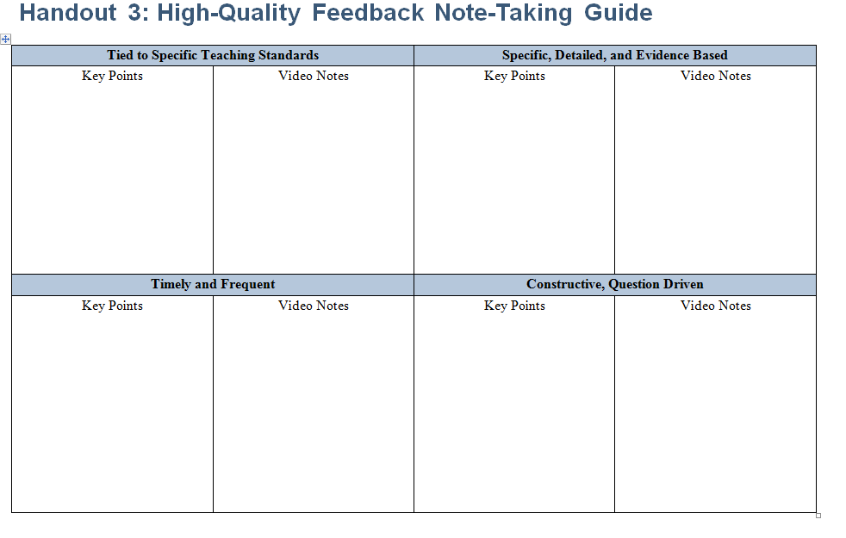

Handout 4: Ms. Blue, Eighth-Grade Mathematics Teacher—Making Sense of the Data
Scenario
Mid-year Data. Ms. Blue is an eighth-grade mathematics teacher in your district. She has 15 years of experience in the district and has been teaching at the same school for the last three years. Ms. Blue’s summative evaluation data for the 2012-13 and 2013-14 school years appear on page 2. She received low ratings in nearly all areas of the observational framework in her first observation of the 2013-14 school year. Her overall Value-Added score (based on data from school years 2012-13 and 2013-14) puts Ms. Blue in the 30th percentile compared with other teachers in the district. This means that her students have shown, on average, less growth than students in other eighth-grade mathematics teachers’ classrooms in the district. There is a relatively large confidence interval around this score, so her true position could be higher or lower.
End-of-Year Data. Ms. Blue’s observational scores improved during the course of the year, and her overall observational score at the end of the year put her in the developing category (but close to skilled category). Combined with her student growth measures, her overall summative rating for 2013-14 was developing.
Professional Learning Resources and Supports. Your school has an instructional coach in mathematics who serves all teachers in the school. Ms. Blue has access to a video library with examples of highly rated practices in each of the areas of the observational framework. There are five professional development release days during the year as well as money in the budget for 100 substitute hours. Ms. Blue’s grade-level team meets for 40 minutes at least twice a month.

Guiding Questions
- Using these data, what should Ms. Blue’s primary professional learning goals be for 2014-15?
- In what key professional learning activities should Ms. Blue participate next year to meet those goals?
- How can the success of the professional learning activities be assessed?

Handout 4: Ms. Blue’s Detailed Summative Evaluation Data
Teacher Evaluation Indicators | 2012-2013 | 2013-2014
Instructional Planning
Focus for Learning | Developing | Developing
Assessment Data | Ineffective | Developing
Prior Content Knowledge/Sequence/Connections | Ineffective | Developing
Knowledge of Students | Developing | Developing
Instruction & Assessment
Lesson Delivery | Ineffective | Developing
Differentiation | Ineffective | Ineffective
Resources | Developing | Developing
Classroom Environment | Developing | Skilled
Assessment of Student Learning | Ineffective | Developing
Professionalism
Professional Responsibilities | Skilled | Accomplished

Teacher Evaluation Indicators | 2012-2013 | 2013-2014
Final Performance Rating | Developing | Developing
Student Growth Measure #1 (Value-Added Measure-Mathematics) | Below Expected (1) | Below Expected (1)
Student Growth Measure #2 (SLO rating– Based on the scores from her 2 SLOs.) | Expected (3) | Expected (3)
Final Summative Rating | Developing | Developing

Handout 5: Orange School—Making Sense of School-Level Data
Teacher | Years of Experience | Instructional Planning: Assessment Data | Instruction & Assessment: Lesson Delivery | Student Growth Measure(s) Rating | Final Summative Rating
A | 13 | Skilled | Skilled | Expected | Skilled
B | 3 | Developing | Developing | Expected | Developing
C | 17 | Skilled | Skilled | Above | Accomplished
D | 23 | Skilled | Skilled | Expected | Skilled
E | 0 | Developing | Ineffective | N/A | Ineffective
F | 23 | Developing | Skilled | Below | Ineffective
G | 28 | Skilled | Skilled | Expected | Skilled
H | 0 | Developing | Developing | N/A | Developing
I | 27 | Skilled | Accomplished | Above | Accomplished
J | 7 | Skilled | Skilled | Expected | Skilled
K | 19 | Skilled | Skilled | Above | Skilled
L | 26 | Skilled | Skilled | Expected | Skilled
M | 34 | Skilled | Skilled | Expected | Skilled
N | 1 | Skilled | Skilled | N/A | Skilled
O | 5 | Developing | Developing | Above | Skilled
P | 15 | Accomplished | Accomplished | Expected | Skilled
Q | 10 | Skilled | Skilled | Expected | Skilled
R | 2 | Developing | Skilled | Below | Developing
S | 19 | Developing | Skilled | Expected | Skilled
T | 36 | Skilled | Skilled | Expected | Skilled
Ms. Blue | 15 | Developing | Skilled | Below | Developing
V | 3 | Skilled | Skilled | Expected | Skilled
W | 11 | Skilled | Developing | Above | Skilled
X | 3 | Developing | Skilled | Expected | Skilled
Y | 1 | Developing | Developing | N/A | Developing
Z | 7 | Developing | Ineffective | Below | Ineffective

*Not to be used to determine Final Summative Ratings, only for use in professional learning decisions

Handout 6: Promising Examples of Systems That Are Creating Conditions for Using Data to Inform Professional Learning
Program 1: Brooklyn Generation School, Brooklyn, New York

Staggered teacher vacations allow 200 days of instruction for students and 20 days of teacher professional learning without making teachers work more or be paid more.

Some classes are taught by teams of teachers with common time to debrief immediately afterward. This shared work time allows teachers to integrate critical data analysis into planning. The daily debrief enables the staff to review the instructional goals, assess students’ progress, and plan.

Dual roles for most staff means that 90 percent of professional staff teach, lowering class size.

For more information
Generation Schools. (2014). Our model [Webpage]. Retrieved from http://www.generationschools.org/about/model/
Silva, E. (2010). Rebuild it and they will come. Educational Leadership, 67(8), 60-65.

Pros & Cons of this strategy:
Program 2: TAP Program Schools

The National Institute for Excellence in Teaching (2012) describes the approach of TAP: The System for Teacher and Student Advancement:
Master teachers spend all or most of their time fulfilling instructional leadership responsibilities, while mentor teachers spend several hours a week on instructional leadership and remain the “teacher-of-record” for one or more classrooms of students. This allows TAP schools to achieve a ratio of about 15 career teachers per master teacher and eight per mentor teacher. Cluster groups typically include one master teacher and one or two mentor teachers…Such ratios ensure that master and mentor teachers are not spread too thinly and can provide at least one coaching session per teacher per week, far more than most coaching strategies manage to provide. The TAP system ensures that master and mentor teachers are not simply “coaches” or “team facilitators,” although they do perform both functions, but true instructional leaders in their schools. (p.14)

For more information
National Institute for Excellence in Teaching. (2012). Beyond “job-embedded”: Ensuring that good professional development gets results. Santa Monica, CA: Author. Retrieved from http://www.niet.org/assets/PDFs/beyon_job_embedded_professional_development.pdf

Pros & Cons of this strategy:

Program 3: Owensboro Public Schools, Owensboro, Kentucky

The district moved to a system of peer mentoring, which helped teachers get used to observing and being observed—which, in turn, helped build a culture of improvement.

“Connect” time—three hours of uninterrupted common time—is built into the weekly schedule through the strategic use of “specials” teachers, guidance counselors, and computer labs, which can accommodate two classes. Also, an arts instruction team of 12 art teachers travels as a group to schools to provide instruction to three grade levels at once to provide vertical collaboration and learning time.

School assemblies provide small pockets of time for status checks on things. If assemblies start at 9a.m, teachers can go to another school and observe other classrooms; then, in the afternoon, teachers go back to their school to teach their students (never missing instructional time with their students).

For more information
Killion, J. (2012). Establishing time for professional learning. Oxford, OH: Learning Forward. Retrieved from http://www.learningforward.org/docs/default-source/commoncore/establishing-time-for-professional-learning.pdf?sfvrsn=6

Pros & Cons of this strategy:

Program 4: Garden Grove Public Schools, Garden Grove, California

Knudsen (2013) describes Garden Grove’s approach:
The most striking feature of any conversation with Garden Grove’s central office administrators is their attention to personal relationships. (p.11)

Evolution over time has led to a philosophy in which district leaders seek to equip teachers to exercise their own professional judgment to facilitate learning. Approaches to instruction include some nonnegotiables—for example, the use of the Effective Instruction framework to structure lessons—and administrators and teacher leaders design many learning opportunities to build teacher skill in using that framework. (p.20)

The word support emerges constantly in conversations with teachers as they describe what it means to work in the district. (p.20)

For more information
Knudsen, J. (2013). You’ll never be better than your teachers: The Garden Grove approach to human capital development. San Mateo, CA: California Collaborative on District Reform. Retrieved from http://www.cacollaborative.org/sites/default/files/CA_Collaborative_Garden_Grove.pdf

Pros & Cons of this strategy:

Questions to consider:
- How do the four examples of promising practices align with the conditions for professional learning identified earlier?
- Which example is worth studying further and potentially applying in your context?

Handout 7: District Professional Learning Self-Assessment
Table A2. District Self-Assessment Tool
Professional Learning Questions for Districts Circle One
Analysis of School Professional Learning Activities  To what extent does your district engage in a structured vetting process to select high-quality professional learning tools, activities, structures, or programs as described in this brief?  Notes: | To a great extent | To some extent | Not at all | Don’t know
Does your district encourage school leaders and teachers to prioritize ongoing professional learning as part of their daily work (through, for example, memoranda, teacher evaluation protocols, district employee policies, school handbooks, and/or the district’s website)?  Notes: | Yes | No | Planned | Don’t know
To what extent does your district use performance metrics to evaluate the impact of professional learning tools, activities, and programs on teacher practice and/or student achievement?  Notes: | To a great extent | To some extent | Not at all | Don’t know
To what extent does your district use this impact information to inform program improvement?  Notes: | To a great extent | To some extent | Not at all | Don’t know
Technical Assistance to Schools  To what extent does your district provide support to principals to select high-quality professional development tools, activities, structures, and programs as described in this brief?  Notes: | To a great extent | To some extent | Not at all | Don’t know
To what extent does your district support principals to structure teachers’ school days to provide time for individual and group professional learning, including opportunities for peer learning (e.g., observing colleagues during planning period or lesson study)?  Notes: | To a great extent | To some extent | Not at all | Don’t know
Alignment with Teacher Evaluation  To what extent does teacher evaluation inform decisions about the types of professional learning activities in which teachers participate?  Notes: | To a great extent | To some extent | Not at all | Don’t know

Reprinted with permission from page 23 of High-Quality Professional Development for All Teachers: Effectively Allocating Resources (http://www.gtlcenter.org/sites/default/files/docs/HighQualityProfessionalDevelopment.pdf)

Handout 8: District Action Plan
Taking Stock
What have I learned in this training that can be applied in my district or building?
What are some opportunities and challenges in moving this effort forward in my district or building?
Initial Action Planning
With whom in my district or building, including teacher leadership, do I share this content? Is this the same group who can implement this effort?
What is the best way to share this module content with those staff?
What structures (policies, programs, practices) are in place that can support this effort?

