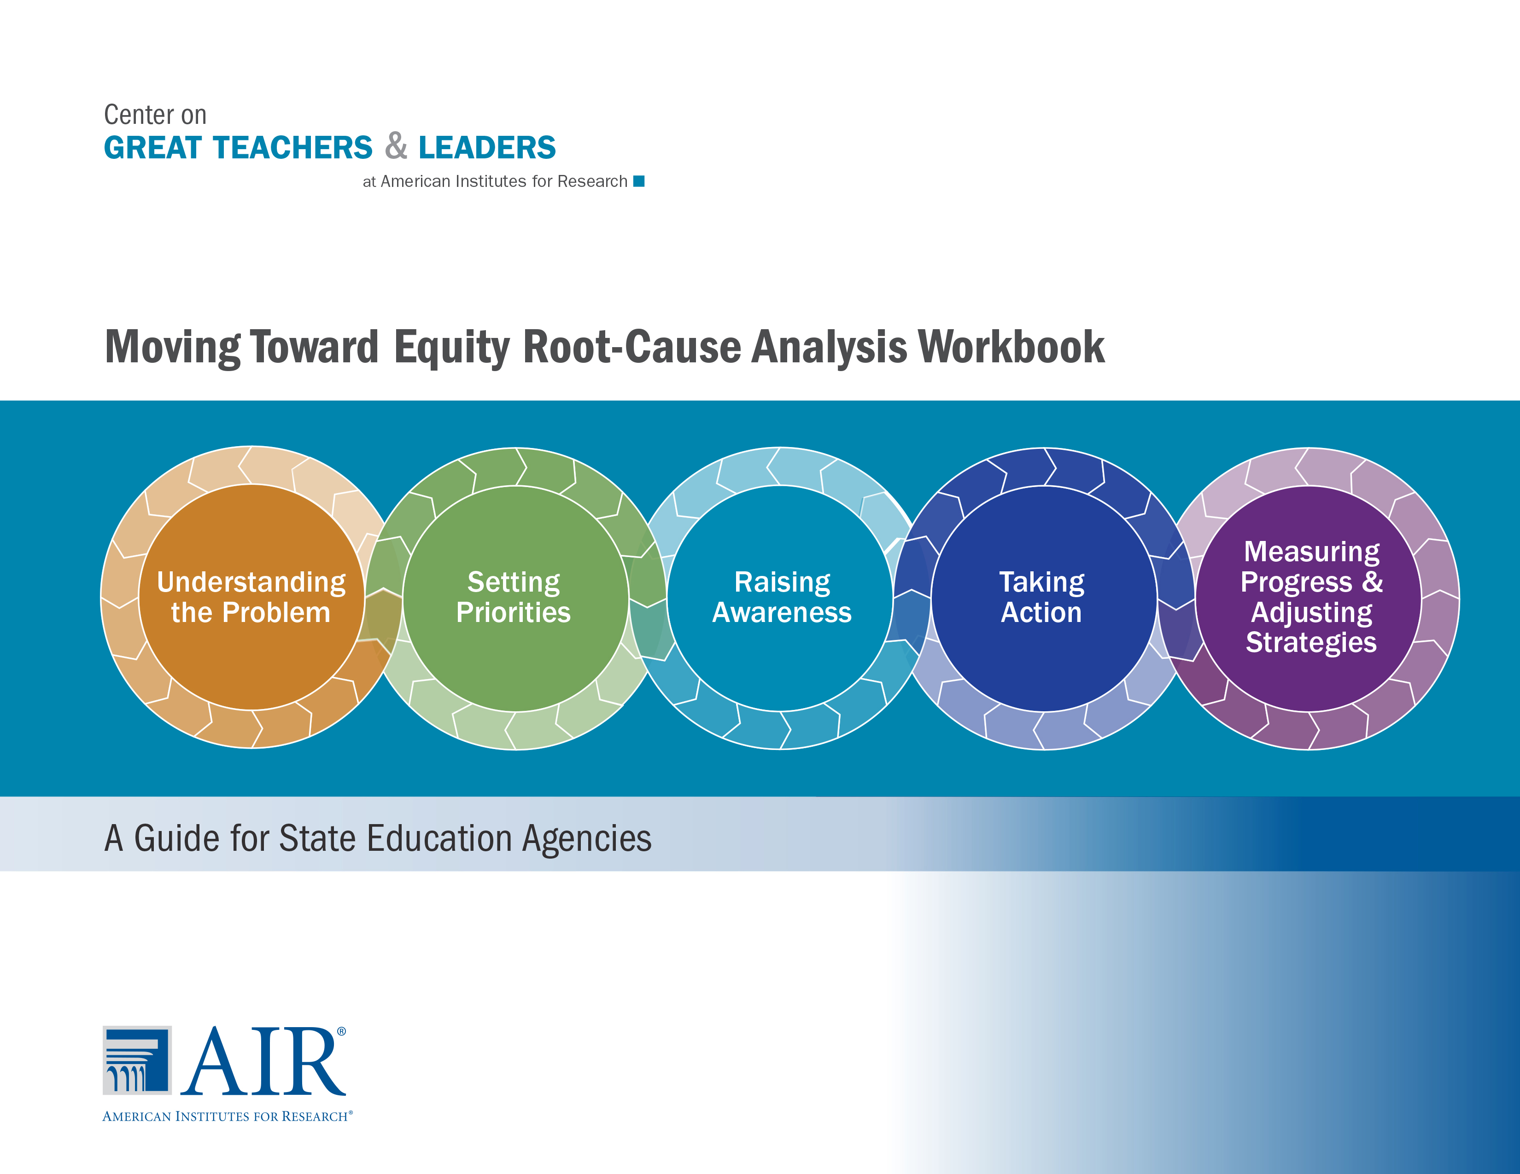
How to Use This Workbook
The Moving Toward Equity Root-Cause Analysis Workbook is set up to be used electronically by a small team of state education agency leaders. You can download the document, open it on your computer, and then input your thoughts and responses directly into the spaces provided. As you write, the spaces will expand to accommodate the added text.
Alternately, the workbook can be printed out. You can write your thoughts and responses by hand into the spaces provided.

Additional Resources
The Moving Toward Equity Root-Cause Analysis Workbook was created for use with the following resources:
- Moving Toward Equity Interactive Online Tool
http://www.gtlcenter.org/learning-hub/moving-toward-equity
- Moving Toward Equity Quick-Start Guide
http://www.gtlcenter.org/sites/default/files/docs/Quick_Start_Guide.pdf
- Moving Toward Equity Technical Assistance Resources Overview
http://www.gtlcenter.org/TA_resources_overview
Companion resources include:
- Moving Toward Equity Stakeholder Engagement Guide
http://www.gtlcenter.org/stakeholder_engagement_guide
- Moving Toward Equity Data Review Tool
http://www.gtlcenter.org/data_review_tool
GTL Center staff are available to provide state education agencies with direct technical assistance in using this workbook and other resources—including stakeholder engagement tools, an equitable access data review tool, and the Talent Development Framework for 21st Century Educators: Moving Toward State Policy Alignment and Coherence. For more information, please contact Ellen Sherratt at esherratt@air.org.

Moving Toward Equity Root-Cause Analysis Workbook:
A Guide for State Education Agencies

November 2014

Contents
Page
Introduction 1
About This Workbook 1
Overall Instructions 2
Step 1: Specify the Challenges to Be Addressed 3
Step 2: Identify Root Causes 4
Step 3: Categorize the Causes 5
Step 4: Visualize Your Causes and Categories 6
Step 5: Determine Strategies for Educator Talent Development 8
Step 6: Create a Theory of Action 9
Step 7: Determine How to Measure Progress 10
Step 8: Put Your Equity Plan Into Motion 12

Introduction
On July 7, 2014, the U.S. Department of Education launched the Excellent Educators for All initiative to help states and school districts support great educators for the students who need them most. This initiative is founded upon the results from several recent studies from the Institute of Education Sciences (IES)[1] and data from the U.S. Department of Education’s Office for Civil Rights[2] demonstrating that inequities in access to great teachers and leaders continue to endure across the United States. Students of color, students from low-income families, rural students, students with disabilities, students with limited English proficiency, and students who are behind academically are less likely than their peers to have access to great teachers and school leaders. The causes of these inequities vary from place to place and context to context, with numerous policy, practice, economic, and sociocultural factors at play. Because of the multiple causes of inequity in access to great teachers and leaders, the solutions must be systemic—rather than treating merely the symptoms.
The Excellent Educators for All initiative calls for states to submit comprehensive educator equity plans describing the steps that state education agencies (SEAs) will take to ensure that children from poor and minority backgrounds are not taught at higher rates than other children by inexperienced, unqualified, or out-of-field teachers. In his July 2014 letter to Chief State School Officers,[3] Education Secretary Arne Duncan stated that to prepare a strong plan, each SEA will analyze what its stakeholders and data have to say about the root causes of inequities.
This guide provides step-by-step considerations to help your SEA prepare to engage in a collaborative process to identify the root causes of inequitable access in your state—to support the development of a strategic, innovative, and context-specific equity plan.

About This Workbook
This workbook is intended to help policy leaders from SEAs unearth the root causes of inequitable access to great teachers and leaders and identify comprehensive talent development solutions. The root-cause analysis process presented in this workbook was adapted from materials developed by the Carnegie Foundation for the Advancement of Teaching and the principles of improvement science.[4] A companion resource for engaging stakeholder groups in a root-cause analysis also is available as part of the Moving Toward Equity: Stakeholder Engagement Guide. This document, titled Resource 7: Engaging Stakeholders in a Root-Cause Analysis, is available online (http://www.gtlcenter.org/resource_7).

Overall Instructions
Follow the eight steps outlined in this workbook to:
- Draw a nuanced picture of the root causes of inequitable access to great teachers and leaders.
- Consider strategies for educator talent development.
- Develop a theory of action for your identified approaches to enhancing equity.
- Determine data points as well as measures for short- and long-term outcomes.
- Put your equity plan into motion.
The completed workbook can be shared with your team members and other stakeholders to gain feedback and build support for your policies. This process will help put your revised comprehensive educator equity plan on the right path.
For more hands-on technical assistance from the GTL Center staff as your SEA team engages in this process, please contact Ellen Sherratt at esherratt@air.org.

Step 1: Specify the Challenges to Be Addressed
Instructions
Reflect on the equitable-access challenges in your state. Brainstorm a list of such challenges, and write them in the box below. Then highlight the one challenge that seems to represent the greatest disparity or seems to be the most immediate and pressing.
Tips
- Specify the problem in terms of a particular problematic equity outcome. For example:
- “There is higher teacher ‘churn’ in priority schools as compared with non-priority schools.”
- “There is lower principal quality in rural schools in Region X than Region V.”
- “Across the state, low-performing students are more likely than high-performing students to be assigned a novice teacher.”
- The specified problem may relate to equitable access at the classroom, school, or district level; and it may relate to access to effective teachers (e.g., teachers who meet a minimum standard of effectiveness) or access to the most outstanding teachers.
- Although the problems in your state may be many, highlight just one primary problematic equity outcome or gap in performance for the purposes of this exercise. (Your team can come back later to conduct a root-cause analysis for the other key equitable access challenges.)
- Use data from state workforce reports or other sources if possible. However, if your state does not have high-quality, relevant data to inform your key equitable access challenges, don’t be deterred from having this conversation now. Instead, rely on the best knowledge of your team based on observations in the field and what data your do have (while, at the same time, making plans to improve the quality of your state’s data over time.
Brainstorm Space: Challenges
L’l’l;’

Step 2: Identify Root Causes
Instructions
Brainstorm the root causes of the challenge identified in Step 1—that is, the reasons why this problematic equity outcome may have occurred. For example, is it because great teachers don’t stay or because underperforming teachers stay too long? Is it that rural school superintendents don’t know how to support educator talent development?
After you’ve written down one explanation for the problematic equity outcome, ask yourself why. Write down a possible reason (even if you don’t know for sure). Keep asking why until you seem to have exhausted the possible causes for the identified problem.
Tips
- For suggestions of root causes, refer to the Moving Toward Equity Quick-Start Guide (http://www.gtlcenter.org/sites/default/files/docs/Quick_Start_Guide.pdf).
- Focus on system challenges, not symptoms. For example, the tendency of early-career teachers to move from inner-city to suburban schools after a few years is a symptom, while a lack of strong preparation and leadership in inner-city schools is a systems challenge. Also, the high percentages of teachers of students with disabilities who leave teaching for work in the private sector is a symptom, while unmanageable caseloads for these teachers is a systems challenge.
Brainstorm Space: Root Causes
[Insert text. Writing space will expand as needed.]

Step 3: Categorize the Causes
Instructions
Look back at the root causes that you listed in Step 2, and consider how you could group these causes into categories. List the categories in the box below.
Tip
- For example, one category of causes might be “lack of talent development opportunities.”
Brainstorm Space: Categories of Root Causes
[Insert text. Writing space will expand as needed.]

Step 4: Visualize Your Causes and Categories
Instructions
Transfer the brainstormed causes and categories to a fishbone diagram (provided on the following page). To insert text into the fishbone diagram, do the following:
- Double-click on the fishbone diagram to open it (rules will appear at the top and left sides of the diagram).
- Position your cursor in a specific box (category) or line (cause), and insert your text within the textbox. (Please keep words to a minimum.)
- Continue inserting your text for each “category” and “cause” as needed in the diagram.
- Then insert text in the “challenge statement” box on the left side.
- Click outside of the fishbone diagram to save your inserts.
- Repeat this process to add more text or change text.
Tip
- This diagram doesn’t have to be perfect on the first try. You may need to create several different versions over time. In fact, you may wish to save different versions of this diagram.

Step 5: Determine Strategies for Educator Talent Development
Instructions
Consider what specific strategies for educator talent development could address one of the categories of causes. Brainstorm a list of possible strategies for educator talent development that are matched to each root cause, and write them in the box below. Afterward, discuss with your colleagues: To what extent are these strategies interdependent?
Tips
- For suggestions of possible strategies for educator talent development, see the Moving Toward Equity Quick-Start Guide (http://www.gtlcenter.org/sites/default/files/docs/Quick_Start_Guide.pdf) as well as the Taking Action page of the Moving Toward Equity online tool (http://www.gtlcenter.org/learning-hub/moving-toward-equity/taking-action).
- Strategies may include things you’re already doing or new ways to enhance existing strategies.
- Consider at which level of the system targeted strategies are most needed (i.e., school level, district level, or state level). This should be informed by data and whether it demonstrates inequities across classrooms within schools, across schools within districts, or across districts in your state.
Brainstorm Space: Educator Talent Development Strategies
[Insert text. Writing space will expand as needed.]

Step 6: Create a Theory of Action
Instructions
Choose a strategy from Step 5 that you believe has potential for high impact on the root cause or causes that you identified. For that strategy, create a theory of action diagram using the boxes below. To add text, position your cursor in the appropriate boxes below.
In the right box, insert your text to indicate the successful outcome after the root cause is addressed. In the middle box, insert your text to indicate the strategy that will address it. In the left box, insert your text to indicate how policy or funding will affect the implementation of the strategy. To save your changes, click outside of the textbox. Please keep words to a minimum.
Tips
- You can start at the right and work left, or start in the middle and work outward, or start at the left and work right―as long as you’re keeping the root cause(s) in mind. (The process is not always as linear as we like to think!)
- For a list of possible policy levers, see the Moving Toward Equity Quick-Start Guide
(http://www.gtlcenter.org/sites/default/files/docs/Quick_Start_Guide.pdf).
- You may want to use Regional Educational Laboratory Pacific’s Education Logic Model Tool (http://relpacific.mcrel.org/ELM.html) to help further articulate your theory of action.

Step 7: Determine How to Measure Progress
Instructions
With your colleagues, discuss the theory of action that you created in Step 6. Answer the following questions:
- How will you know whether you addressed the root causes?
- What data will you need?
- What will characterize success?
- What is a realistic time period to realize success?

Then fill out the table on the following page to indicate your short- and long-term outcome measures. In other words, what is the change you want to see in the world and how can you prove that you made it?
Tips
- Identify specific data points. For example:
- “Teacher attrition rates roughly equal in every high school across the state”
- “Teachers’ perceptions of leadership quality are roughly equal in high-poverty schools (e.g., top quintile for percentage of students receiving free or reduced-price lunch) and low-poverty schools”
- For a detailed list of data points to consider, please review the companion resource titled Equitable Access: Example and Priority Metrics (http://www.gtlcenter.org/example_priority_metrics).
- If necessary, adjust the time spans (e.g., 2 months, 1 year) to reflect when you expect to see observe positive outcomes as a result of your state’s interventions (e.g., as a result of the strategies that you adopt). Keep the time spans ambitious but reasonable.

Short- and Long-Term Outcome Measures
Evidence of Impact | 1 Month  Into Intervention | 6 Months  Into Intervention | 12 Months  Into Intervention | 2 Years  Into Intervention
Data Point 1:  (Identify data point.) | [Insert text.] | [Insert text.] | [Insert text.] | [Insert text.]
Data Resource Notes:  (How can you obtain these data? What resources do you need?) | [Insert text.] | [Insert text.] | [Insert text.] | [Insert text.]
Data Point 2:  (Identify data point.) | [Insert text.] | [Insert text.] | [Insert text.] | [Insert text.]
Data Resource Notes:  (How can you obtain these data? What resources do you need?) | [Insert text.] | [Insert text.] | [Insert text.] | [Insert text.]
Data Point 3:  (Identify data point.) | [Insert text.] | [Insert text.] | [Insert text.] | [Insert text.]
Data Resource Notes:  (How can you obtain these data? What resources do you need?) | [Insert text.] | [Insert text.] | [Insert text.] | [Insert text.]

Step 8: Put Your Equity Plan Into Motion
Instructions
Use your theory of action (Step 6) to share your vision, garner support, take action, and test your hypotheses. The theory of action can form the basis of your equity planning communications and messaging, your meetings with stakeholders, and―ultimately―the comprehensive educator equity plan that your state submits and sees through. Take a few moments to envision when and with whom you could share the theory of action to maximize its potential to spark the change you want to see.
Tips
- The equity plan doesn’t have to be fancy, but it should consist of specific outcomes—for example, the change you want to see in your state or region, a well-articulated strategy, the resources or contexts that are brought to bear.
- For tips on messaging about your state’s equity planning, see Step 3 of Resource 1: Four Key Steps for Equitable Access Communication Planning (http://www.gtlcenter.org/resource_1).
- For tips on engaging stakeholders in the equity planning process, see the Moving Toward Equity Stakeholder Engagement Guide (http://www.gtlcenter.org/stakeholder_engagement_guide).
Brainstorm Space: Plan
[Insert text. Writing space will expand as needed.]

Take Action Toward Equity With Comprehensive Talent Development
The Moving Toward Equity online tool (http://www.gtlcenter.org/learning-hub/moving-toward-equity) helps you set priorities and explore potentially effective strategies to ensure that all students have access to truly great teachers and leaders. It is important to note, however, that achieving equitable access to great teachers and leaders is not possible unless all educator talent development strategies are working in concert. For example, an innovative recruitment incentive program to attract great teachers will be undone by a lack of career advancement opportunities that allow great teachers to lead while continuing to teach.
The GTL Center has developed the Talent Development Framework (see graphic below) to emphasize the many components that ensure teacher growth. Our vision is that one day, all educators will have access to a coherent talent development system that narrows the educator effectiveness gap, so no child will lack for great teachers who are supported by great principals. Meanwhile, we must focus our resources and talent on those students whose futures are diminished every day by a lack of access to truly effective educators.
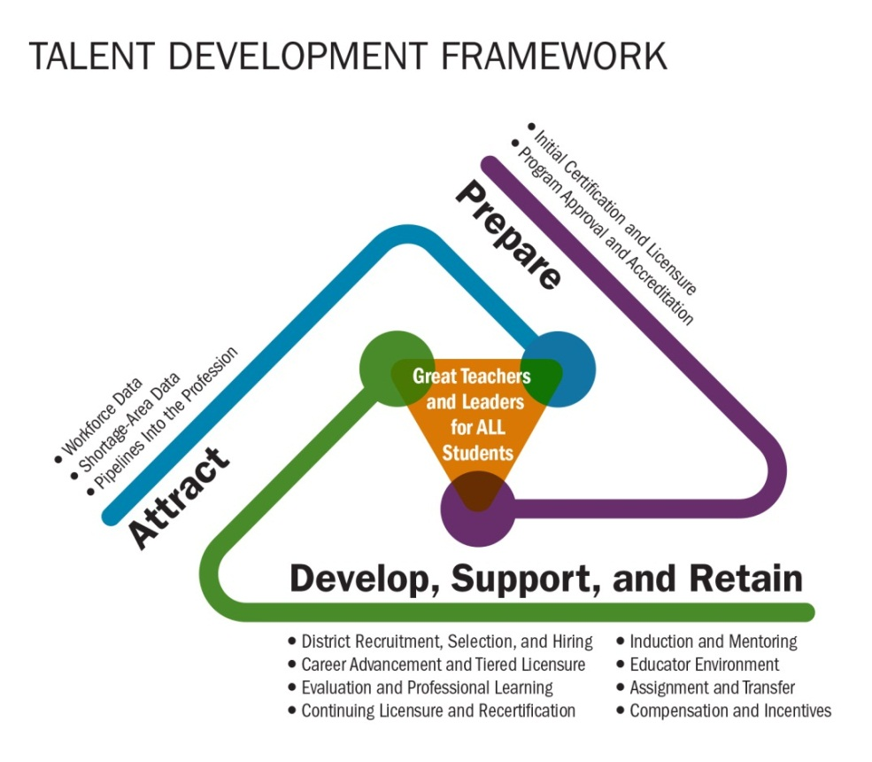

[1] The IES brief outlining these studies is available online (http://ies.ed.gov/ncee/pubs/20144010/pdf/20144010.pdf).
[2] This data snapshot from the Office for Civil rights is available online (http://www2.ed.gov/about/offices/list/ocr/docs/crdc-teacher-equity-snapshot.pdf).
[3] The letter to Chief State School Officers from Secretary Duncan is available online (http://www2.ed.gov/policy/elsec/guid/secletter/140707.html).
[4] For more information on improvement science and its use in education reform, refer to the book Improving: Helping Our Schools Get Better at Getting Better by A. S. Bryk, L. Gomez, A. Grunow, and P. LeMahieu (Harvard Education Press, forthcoming).

