Handout 2: District and State Actions Supporting Principal Turnaround Leadership
Figure 1. Principal Turnaround Actions From the Center for School Turnaround
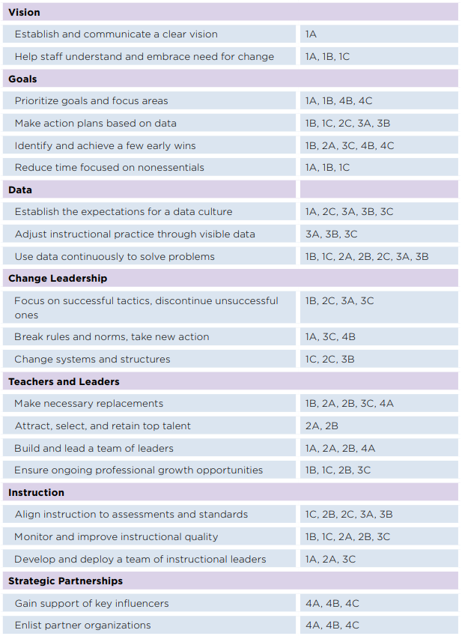
Source: The Center on School Turnaround. (2017). Examples of actions taken by principals trying to lead turnaround. Retrieved from http://centeronschoolturnaround.org/wp-content/uploads/2017/11/CST_Examples-of-Actions_Principals.pdf
Figure 2. State, District, and School Turnaround Practices Aligned to School Leader Roles in Mentoring and Induction Programs
Role in Mentoring and Induction | Rapid School Improvement Indicators
 | School Level | District Level | State Level
School Culture
Promote and model a school culture of trust:  - Show support for taking instructional risks.  - Show support for “failing forward.” | Indicator Sc-1A.1: School leadership sets a clear direction for the school with a stated vision, theory of action, goals, and strategies for rapid and sustained improvement.  - Sources of Implementation Evidence Sc-1A.1: Direction document, agendas, and meeting minutes demonstrating where the vision has been shared | Indicator Di-1A.1: District leadership sets a clear direction for the district with a stated vision, a theory of action, goals, and strategies for the district’s continuous and sustained improvement.  - Sources of Implementation Evidence Di-1A.1: Direction document, agendas, and meeting minutes demonstrating where the vision has been shared | Indicator St-1A.1: State leadership sets a clear direction for the state with a stated vision, theory of action, goals, and strategies for the state’s continuous and sustained improvement.  - Sources of Implementation Evidence St-1A.1: Direction document, agendas, and meeting minutes demonstrating where the vision has been shared
Promote a school culture that values innovation:  - Offer formal and informal opportunities for listening to new teachers.  - Try out ideas from new teachers. | Indicator Sc-4A.1: All school personnel are organized into teams with clearly defined purposes (related to improving practice in order to enhance student learning), regular meeting times, and work products.  - Sources of Implementation Evidence Sc-4A.1: Team descriptions, rosters, agendas, minutes, and team work products | Indicator Di-4A.1: District policy includes description of required structures, purposes, meeting times, and work products for both district and school teams that focus on improving practice to enhance student learning.  - Sources of Implementation Evidence Di-4A.1: District policy accessible to district and school teams | Indicator St-1A.4: State develops and communicates a guiding framework (including roles, responsibilities, and expectations) for districts and also for regional centers’ oversight and support of school-level turnaround efforts.  - Sources of Implementation Evidence St-1A.4: State’s framework and its communication plan; examples of communications of the framework to districts and/or regional centers  Indicator St-4A.1: State produces and disseminates samples of exemplary district policy and district/school practice regarding team structures, role expectations, and methods for recognizing academic achievement.  - Sources of Implementation Evidence St-4A.1: Examples available on the state website
Make mentoring activities part of normal school culture:  - Show support for collaboration between all teachers. | Indicator Sc-4A.1: All school personnel are organized into teams with clearly defined purposes (related to improving practice in order to enhance student learning), regular meeting times, and work products.  - Sources of Implementation Evidence Sc-4A.1: Team descriptions, rosters, agendas, minutes, and team work products  Indicator Sc-4A.2: A team including teacher and parent representatives oversees school-home relationships that enhance student learning and operates with clearly defined purposes (related to improving practice in order to enhance student learning), regular meeting times, and work products.  - Sources of Implementation Evidence Sc-4A.2: Team description, rosters, agendas, minutes, and team work products | Indicator Di-4A.1: District policy includes description of required structures, purposes, meeting times, and work products for both district and school teams that focus on improving practice to enhance student learning.  - Sources of Implementation Evidence Di-4A.1: District policy accessible to district and school teams  Indicator Di-4A.2: District policy includes guidelines for each school’s School Leadership Team to clearly define, document, and annually review roles, responsibilities, and expectations relative to students’ learning for administrators, teachers, parents/caretakers, staff, volunteers, and students.  - Sources of Implementation Evidence Di-4A.2: District policy | Indicator St-4A.1: State produces and disseminates samples of exemplary district policy and district/school practice regarding team structures, role expectations, and methods for recognizing academic achievement.  - Sources of Implementation Evidence St-4A.1: Examples available on the state website  Indicator St-4A.2: State provides professional learning opportunities for district personnel to develop policies and products that promote student learning through effective teams, clear role expectations, position descriptions, and evaluation criteria.  - Sources of Implementation Evidence St-4A.2: Descriptions and schedule of professional learning activities
School Processes and Schedules
Establish clear communication and leadership structures:  - Create clear roles and processes for communication and decision making across and between teachers, mentors, and administrators. | Indicator Sc-1A.3: Communication strategies, as outlined in a plan developed by school leadership, are used to routinely share improvement priorities across faculty and staff, with students and with the school’s broader community.  - Sources of Implementation Evidence Sc-1A.3: Communication plans; examples of communications to staff, faculty, and community articulating improvement priorities (e.g., e-mails, letters, staff/community meeting minutes)  Indicator Sc-2C.3: School Leadership Team examines, at least once a semester, teacher and leader role descriptions and commitments so that responsibilities can be equitably distributed.  - Sources of Implementation Evidence Sc-2C.3: Documentation of a commitment analysis and resulting recommendations for responsibility redistribution | Indicator Di-1A.3: District leadership convenes public forums and invites stakeholders, including parents and neighborhood leaders, to inform context, policy, equitable resource distribution, and implementation of turnaround efforts.  - Sources of Implementation Evidence Di-1A.3: Descriptions, schedules, and materials related to public forums, including list of participants and minutes of meetings  Indicator Di-2C.3: District provides example calendars and schedules for schools that reflect effective use of teacher time, including time for teacher collaboration, professional learning, and review of student data.  - Sources of Implementation Evidence Di-2C.3: Daily, weekly, and monthly school calendars | Indicator St-1A.3: State communicates and advocates for public commitment to turning around low-achieving schools.  - Sources of Implementation Evidence St-1A.3: Public communications (media articles; presentations, speeches; letters to stakeholders, including parents) advocating for the need for school turnaround and public commitment to it  Indicator St-2C.3: State provides example job descriptions that reflect realistic and high-leverage responsibilities for district and school improvement and turnaround staff.  - Sources of Implementation Evidence St-2C.3: Job and role descriptions
Align schedules and calendars:  - Make regular time available for mentoring activities.  - Create extra time for mentor support during “pain points” in the year (e.g., parent-teacher conferences, preparing for key assessments). | Indicator Sc-2C.2: School Leadership Team develops and implements schedules to reflect effective use of teacher time, including time for teacher collaboration, professional learning, and review of student data.  - Sources of Implementation Evidence Sc-2C.2: Daily, weekly, and monthly school calendars | Indicator Di-2C.3: District provides example calendars and schedules for schools that reflect effective use of teacher time, including time for teacher collaboration, professional learning, and review of student data.  - Sources of Implementation Evidence Di-2C.3: Daily, weekly, and monthly school calendars | Indicator St-2C.3: State provides example job descriptions that reflect realistic and high-leverage responsibilities for district and school improvement and turnaround staff.  - Sources of Implementation Evidence St-2C.3: Job and role descriptions
Align policies and practices:  - Streamline goal-setting processes.  - Ensure evaluation policies are role specific. | Indicator Sc-1C.3: School plans and implements improvement strategies that are focused on student learning needs and tailored to address the professional learning needs of individual teachers.  - Sources of Implementation Evidence Sc-1C.3: School improvement plan and professional learning plans for staff | Indicator Di-1C.3: District provides information and opportunities for schools (e.g., principals, staff, or leadership teams) to learn lessons derived from school improvement implementation across schools, including alongside and from one another.  - Sources of Implementation Evidence Di-1C.3: Districtwide technical assistance plans and documents for professional learning | Indicator St-1C.3: State’s system of support is sufficiently differentiated in identifying and responding to improvement needs of districts and schools.  - Sources of Implementation Evidence St-1C.3: Operations documents for the state system of support, including its theory of action, needs assessment processes, and methods for identifying and responding to each district and school’s improvement needs
Supporting Mentor
Set expectations for the mentor role:  - Clearly define mentor activities and how they fit into a typical work day.  - Clearly define expectations for information sharing and communications with teachers and leaders. | Indicator Sc-2C.1: School Leadership Team provides clear, written expectations for teachers and leaders in terms of roles, effort, and expected outcomes.  - Sources of Implementation Evidence Sc-2C.1: Job and role descriptions | Indicator Di-2C.1: District-level roles, designated by district leadership, contribute to and support school improvement and turnaround efforts, with an appropriate proportion of job responsibilities committed to these efforts.  - Sources of Implementation Evidence Di-2C.1: Job and role descriptions | Indicator St-2C.1: State develops and disseminates protocols to guide districts and schools in analyzing role expectations specific to improvement and turnaround efforts.  - Sources of Implementation Evidence St-2C.1: Materials and description of dissemination efforts
Select mentors based on  - Knowledge, skills, and abilities aligned with mentor competencies and standards  - Dispositions (e.g., growth mindset, dedication to the profession)  - Rapport with other teachers (e.g., reputation, respect) | Indicator Sc-2A.2: School leadership hires teachers and leaders from an identified talent pool for turnaround contexts developed by the district and conducts its own recruitment to ensure a staff of teachers and leaders well matched to school needs.  - Sources of Implementation Evidence Sc-2A.2: Counts and documentation of hiring source for teacher, teacher leader, coach, and assistant principal positions | Indicator St-2A.2: State provides professional learning opportunities for district personnel to understand turnaround competencies and how to develop them in teachers and leaders.  - Sources of Implementation Evidence St-2A.2: Descriptions and schedules of professional learning activities | Indicator Di-2A.2: District policies, programs, and procedures include those for identifying and developing turnaround talent.  - Sources of Implementation Evidence Di-2A.2: District policies and program descriptions related to turnaround talent development
Create feedback loops with mentors:
- Create structures for information sharing.
- Establish decision-making protocols.
- Create structures to gather information and reflect on mentor development needs.
Provide professional learning and support to mentors:  - Offer individualized support and thought partnership.  - Make time for district- and state- level opportunities for professional learning. | Indicator Sc-2A.3: Teachers and leaders are engaged in professional development opportunities that include strategies to succeed in the turnaround environment.  - Sources of Implementation Evidence Sc-2A.3: Description of these activities and related procedures that are routine in the school  Indicator Sc-2B.1: School Leadership Team meets at least quarterly to review data to inform professional learning opportunities for teachers and make recommendations in rapid response to identified needs, as aligned with the school’s turnaround priorities.  - Sources of Implementation Evidence Sc-2B.1: Agendas and notes of meetings that analyzed the data and reports of professional learning recommendations  Indicator Sc-2B.2: School Leadership Team engages in learning opportunities with teachers to learn together and reflects with them on professional practice (e.g., coaching, mentoring, observation).  - Sources of Implementation Evidence Sc-2B.2: Schedules, rosters, and documents for professional learning  Indicator Sc-2B.3: School Leadership Team seeks out, and provides access to, professional learning opportunities that are differentiated, purposeful, effective, and high quality to benefit faculty both individually and collectively.  - Sources of Implementation Evidence Sc-2B.3: Schedules and documents related to professional learning | Indicator Di-2A.3: District uses multiple measures and data sources to assess teacher and leader turnaround competencies, with special attention to readiness and potential, and uses these tools to identify and develop teachers and leaders to serve in turnaround contexts.  - Sources of Implementation Evidence Di-2A.3: Assessment criteria and tools  Indicator Di-2B.1: District policy specifies that each school will regularly examine and annually report on how it is using data to identify the professional learning needs of each teacher and using these data to rapidly respond with professional learning opportunities aligned with the school’s turnaround priorities.  - Sources of Implementation Evidence Di-2B.1: Policy and reporting timelines  Indicator Di-2B.2: District offers all district staff high-quality, relevant, and job-embedded professional learning opportunities, including some opportunities to engage in professional learning with school leaders and teachers.  - Sources of Implementation Evidence Di-2B.2: Schedules and documents related to professional learning  Indicator Di-2B.3: District provides or supports, evaluates, and continuously improves professional learning opportunities for district and school personnel that are differentiated, purposeful, effective, and high quality.  - Sources of Implementation Evidence Di-2B.3: Schedules and documents related to professional learning | Indicator St-2A.3: State provides and/or supports programs to prepare and develop turnaround leaders.  - Sources of Implementation Evidence St-2A.3: Program descriptions, schedules, agendas, and participation records  Indicator St-2B.1: State provides districts and schools with examples of how districts and schools have implemented effective professional learning opportunities.  - Sources of Implementation Evidence St-2B.1: Examples and description of how they are disseminated  Indicator St-2B.2: State provides training for districts and schools in developing and implementing a professional learning approach that is (1) based on identified needs and (2) offers effective, high-quality professional learning opportunities for teachers and leaders.  - Sources of Implementation Evidence St-2B.2: Descriptions and schedules of professional learning  Indicator St-2B.3: State’s trainings and learning opportunities embody the principles of effective professional learning, including reflective practice and structures to encourage individual and collective growth.  - Sources of Implementation Evidence St-2B.3: Descriptions and schedules of professional learning

