Applying Knowledge on Sustainability & Scale Up
How to Take Your Implementation to the Next Level

Edward Dieterle, Ed.D.
ed.dieterle@gmail.com

November 16, 2018

Session Objectives
- Overview of research on sustainability & scale up
- Top challenges & stumbling blocks
- Strategies for overcoming challenges

Factors Associated with Scale
Based on the research of Coburn, Dede, and others (Coburn, 2003; Dede, Honan, & Peters, 2005; Dede, Rockman, & Knox, 2007)
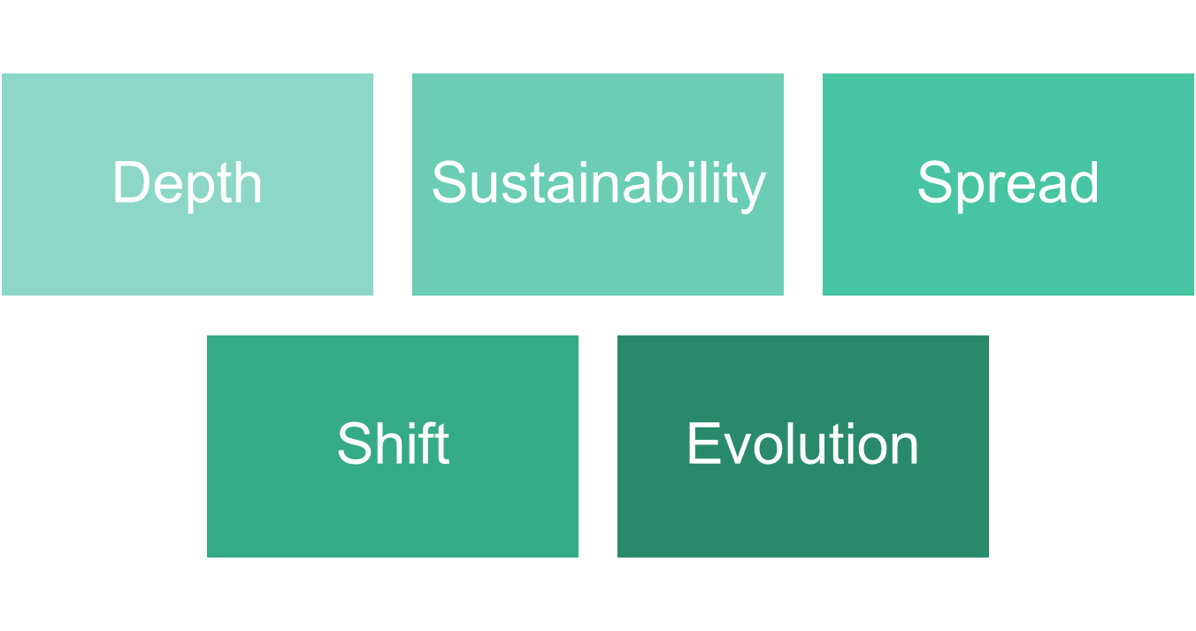

Definitions
Depth: Deep scale produces deep and consequential changes in practice
Sustainability: Sustained scale means maintaining changes in practice over substantial periods of time
Spread: Spread is the diffusion of the innovation to large numbers of users
Shift: Ownership of the innovation is assumed by users, whose identity becomes associated with the innovation
Evolution: The innovation revised by its adapters influences and reshapes the thinking of decisionmakers
Depth
Deep scale produces deep and consequential changes in practice

Action
- Focus on best practices associated with behavior change; avoid perfection seeking

Question
- As you implement your T4TLA strategy, how and in what ways are educators being asked to change their behaviors?
- What are you doing to support these changes in behavior?
- What else will you do this year to support the changes in behavior that you want and expect?
Two Questions Highly Correlated with Behavior Change
Answering yes to, “I believe it can be done,” and, “I value it,” will maximize the likelihood of behavior change. The following diagram and related questions is based on the lifelong work of Albert Bandura (1977, 1986, 1989).
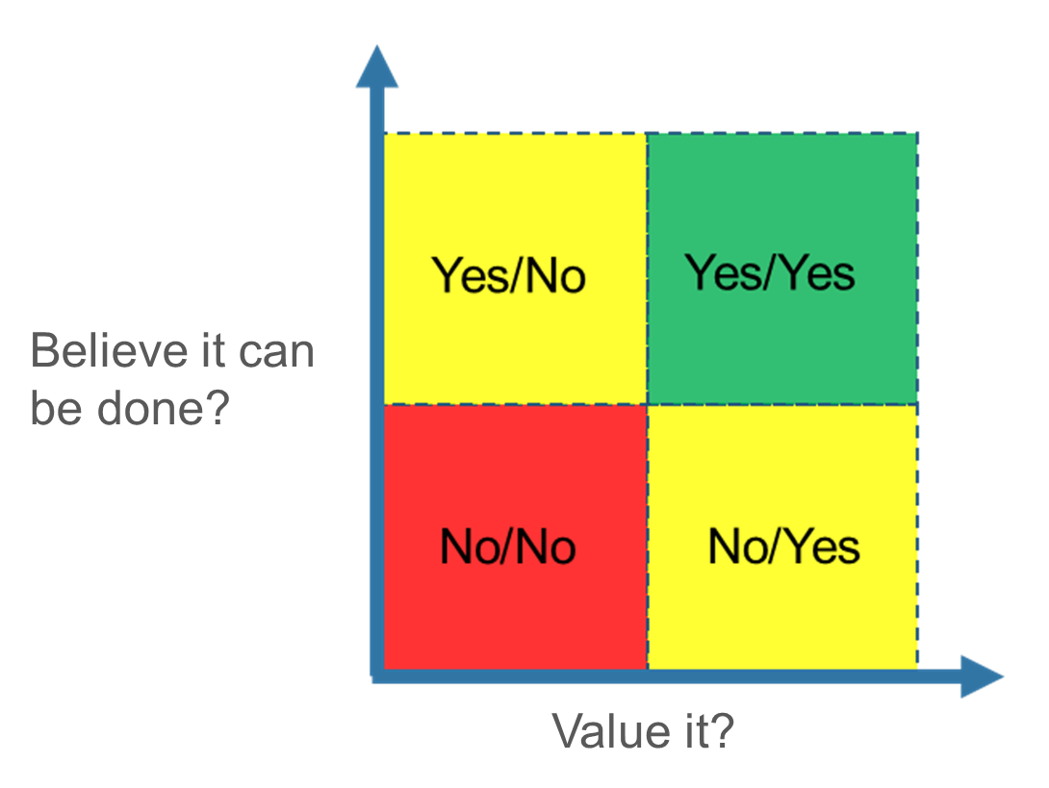

Sustainability
Sustained scale means maintaining changes in practice over substantial periods of time

Action
- Ensure innovations are robust enough to survive negative shifts in context

Questions
- To what extent does the innovation present a viable economic and technical solution?
- To what extent does it align to existing cultural, psychological, and political forces?
- What are some potential threats to the sustainability of your T4TLA strategy over the long-term?
- What can/will you do to mitigate these threats?
Sustainability Example 1
A handheld graphing calculator can be found in most advanced high school math classes. It is capable of plotting graphs, solving simultaneous equations, and performing other tasks with variables (Desta, 2014). It and a textbook cost roughly the same. It works right out of the box and requires minimal technical upkeep. Professional development opportunities coupled with calculator-infused curricula provided educators the skills and materials they need to integrate graphing calculators into their classrooms. Graphing calculators, in general, have avoided becoming political lightning rods.
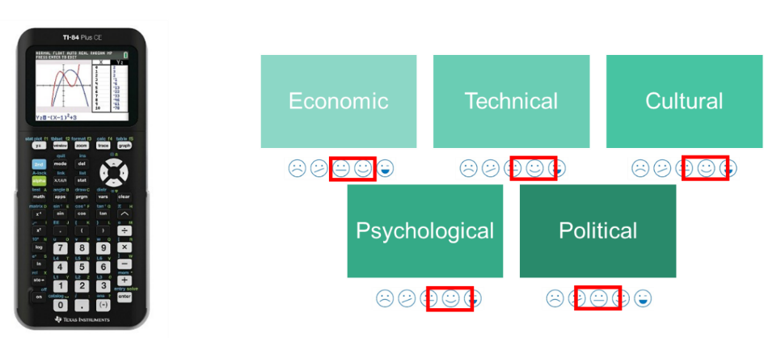
Sustainability Example 2
The Information Awareness Office, known more commonly as Total Information Awareness, was a program administered by the Defense Advanced Research Projects Agency (DARPA) and defunded by Congress (Kessler, 2015). It applied data mining techniques to data generated by unknowing citizens.
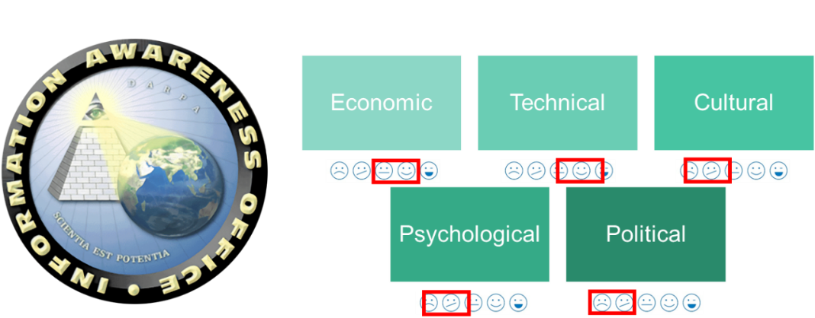
Spread
Spread is the diffusion of the innovation to large numbers of users

Actions
- Focus on the majority and not the extremes
- Seek modification of the innovation that retain effectiveness while reducing the resources and expertise required

Questions
- What percentage of educators are adopters of your T4TLA innovation?
- What is the value of your T4TLA innovation in relation to alternatives?
- Will/how will you spread your T4TLA strategy to schools that are high performing?
- Will/how will you modify the strategy to meet the needs of high performing schools?
Diffusion and Adoption
To self-sustain, the T4TLA innovation must be widely adopted, reaching critical mass. Rogers (2003) argues that diffusion is the process by which participants in a social system communicate and socialize an innovation among one another over time. Four elements influence the spread of a new idea: (a) the innovation itself, (b) communication channels, (c) time, and (d) the social system. This process relies on human capital: the skills, knowledge, and experience possessed by an individual in the social system or the social system itself.
Not all T4TLA educators will embrace your strategy and associated innovations equally. Some educators will more quickly take to innovations, while others are resistant. Within the rate of adoption, there are innovators, early adopters, early majority, late majority, and laggards.

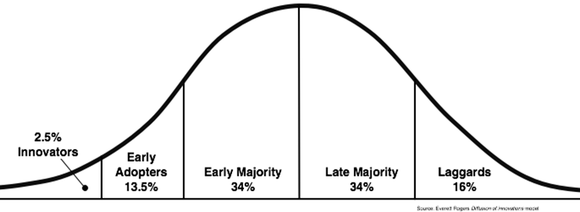

What is the Value of the Learning Innovation?
Introducing a new strategy or innovation into a system often means letting go of an existing strategy or innovation. One way of making the case for change is comparing and contrasting the value of different strategies or innovations.

Questions
- What are the benefits on learning?
- What are the costs associated with the innovation?
- With a measure of benefit and a measure of cost, we can calculate the value.
  - $Value= \frac{Benefits}{Costs}$

Calculating and tabulating value scores supports compare-and-contrast conversations.
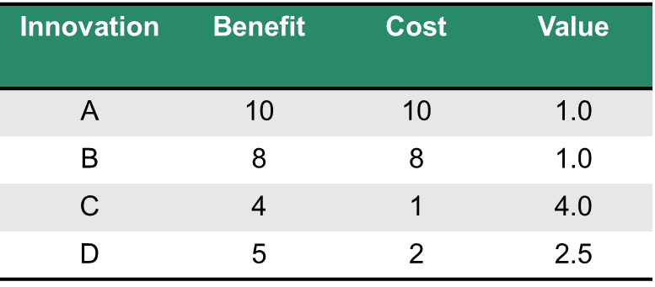

Shift
Ownership of the innovation is assumed by educators, whose identity becomes associated with the innovation

Action
- Decisionmakers need to support a shift in the identity of T4TLA educators

Questions
- Will/how will you support T4TLA educators’ shift their identity?
Shift and Identity
Individuals tend to engage in activities that connect them to their social identities because doing so can support their sense of belonging and how they see themselves. This integration and shift in identity involves taking on the knowledge, goals, and practices valued by that group (Lave & Wenger, 1991; National Research Council, 2018; Wenger, 1998).
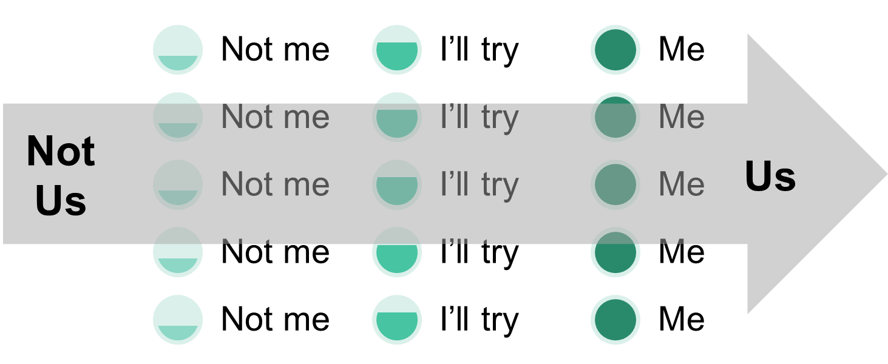
Shift and Proficiency
A shift in identity can include a shift in proficiency. The National Institutes of Health (2009) developed the following scale that organizes what individual know and are able to into five levels of proficiency. You can use this scale to measure and track changes in T4TLA educators’ proficiency over time.
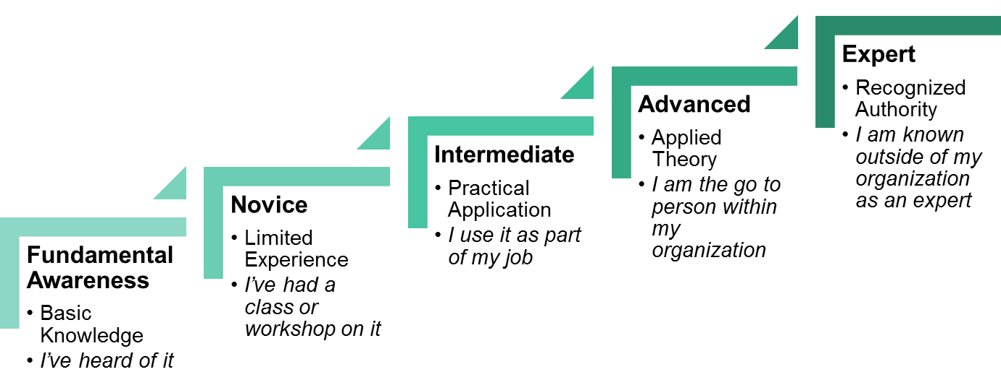
Evolution
Evolution is the process through which your T4TLA strategy and associated innovations change over time

Actions
- Learning from T4TLA educators’ adaptations to rethink the innovation’s model
- Conduct research and evaluation on features of the T4TLA strategy and associated innovations to understand and enhance the causes of effectiveness

Questions
- Will/how will you document and investigate your T4TLA strategy?
- Will/how will you use knowledge generated from the investigation of your T4TLA strategy to improve it?
- Will/how will you unlearn your initial beliefs, values, and assumptions about the T4TLA strategy and associated innovations, and generate willingness to start the innovation process over again?

Research and Evaluation
- What features of the innovation are associated with its effectiveness?
- What conditions does each feature depend on for success?
- How sensitive is each feature to these conditions?
Logic Model for an Innovation
A logic model is a graphical representation of a program that connects the needs of stakeholders, to the activities of those associated with the T4TLA strategy, and the resulting outcomes and impacts.
A needs assessment determines the gaps between current and desired conditions. Without a needs assessment, a solution might be technically and statistically significant, but worthless to the target audience. A process evaluation investigates the implementation of program activities. Without knowing the how, it is hard to interpret outcome and impact measures. Outcome evaluations measures program outcomes (e.g., teacher attrition rate, state summative test scores). Impact evaluations compare the outcomes of those provided the innovation (i.e., the treatment group) and those who did not (i.e., the control group).
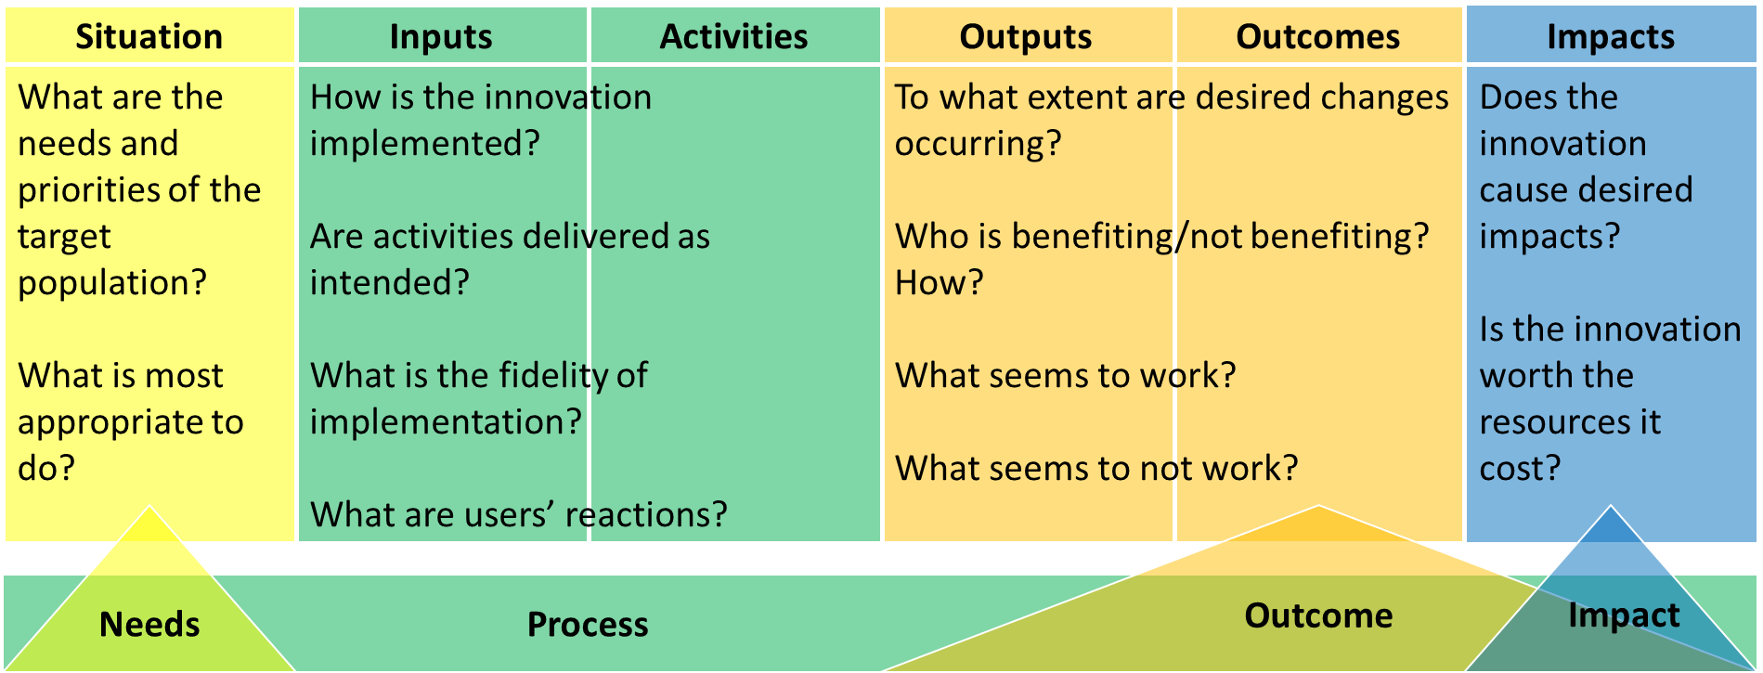

References
Bandura, A. (1977). Self-Efficacy: Toward a Unifying Theory of Behavioral Change. Psychological review, 84(2), 191-215.
Bandura, A. (1986). Social Foundations of Thought and Action: A Social Cognitive Theory. Englewood Cliffs, NJ: Prentice-Hall.
Bandura, A. (1989). Regulation of Cognitive Processes Through Perceived Self-Efficacy. Developmental psychology, 25(5), 729-735.
Coburn, C. (2003). Rethinking Scale: Moving Beyond Numbers to Deep and Lasting Change. Educational researcher, 32(6), 3-12.
Dede, C., Honan, J. P., & Peters, L. (Eds.). (2005). Scaling up Success : Lessons Learned from Technology-Based Educational Improvement. San Francisco, CA: Jossey-Bass.
Dede, C., Rockman, S., & Knox, A. (2007). Lessons Learned from Studying How Innovations Can Achieve Scale. Threshold, 5(1), 4-10.
Desta, Y. (2014). Why the TI Graphing Calculator Ruled Your Classroom. Retrieved from https://mashable.com/2014/06/03/ti-calculator-evolution/#Zvji_eRXRZqa
Kessler, M. (2015). The Logo That Took Down a DARPA Surveillance Project. Retrieved from https://www.theatlantic.com/technology/archive/2015/12/darpa-logos-information-awareness-office/421635/
Lave, J., & Wenger, E. (1991). Situated Learning: Legitimate Peripheral Participation. New York, NY: Cambridge University Press.
National Institutes of Health. (2009). Competencies Proficiency Scale. Retrieved from https://hr.nih.gov/working-nih/competencies/competencies-proficiency-scale
National Research Council. (2018). How People Learn II. Washington, DC: National Academies Press.
Rogers, E. M. (2003). Diffusion of Innovations (Fifth Ed.). New York, NY: Free Press.
Wenger, E. (1998). Communities of Practice: Learning, Meaning, and Identity. New York, NY: Cambridge University Press.

