Principal Hiring Scorecard
A high-quality principal hiring process has far-ranging impacts on the leadership and student learning in a given school. The principal hiring should be fair, rigorous, and data-driven, and its results should inform new principal induction and mentoring processes.
The first step in developing a strong principal hiring process is to identify the strengths and areas of growth for your district’s current principal hiring process. What elements of the process does your district currently do well? What aspects can your district improve upon? To find out, take the following survey.
*Note: This survey has been adapted for the Center on Great Teachers and Leaders Professional Learning Module: Using Turnaround Leader Competencies to reflect the use of turnaround principal competencies in the principal hiring process.

Survey
Instructions: For each question, please circle the response that best describes the principal hiring process in your district. There are no right or wrong answers.
When you have finished, use the scoring guide at the end of the survey to access the quality of your district’s principal hiring process.
- Outside Recruitment
  - There is no central source for handling the recruitment process, and recruitment is typically done through word of mouth and with advertisements in the local newspapers. We primarily publicize openings in one or two venues.
  - We have a principal recruitment plan that is coordinated by a single office or officer. The district uses word of mouth and print advertising to publicize openings, but it also publicizes through school/district and state education agency websites and state postings at universities or colleges. We use a mix of methods (more than two or three), and we publicize within our athletic conference and the state.
  - We have a principal recruitment plan that is coordinated by a single office or officer, and we conduct a targeted search based on school/district leadership needs. The district uses a mix of methods to publicize openings, including word of mouth, print advertising, websites, and job fairs. We publicize within our athletic conference, across the state, and occasionally at national levels. *Recruitment materials include turnaround principal actions and competencies.

- Internal Recruitment
  - We encourage candidates within the district or school to apply for open positions. All candidates, of course, must meet basic qualifications. We do not have a structured process in place to build teacher-leader or assistant principal skills and knowledge to prepare them to become principals. We provide incentives to assistant principals and teachers so that they are encouraged to obtain their administrative licenses.
  - We encourage candidates within the district or school to apply for open positions, and all candidates must meet basic qualifications. We have trained current principals to mentor assistant principals and teachers to build their skills as leaders, but we do not have performance evaluation processes in place to determine whether or not new leaders are capable and effective. Special leadership positions or additional responsibilities are not available to new leaders. We provide incentives to assistant principals and teachers so that they are encouraged to get their administrative licenses.
  - We encourage candidates within the district or school to apply for open positions, and all candidates must meet basic qualifications. We provide incentives to assistant principals and teachers so that they are encouraged to get their administrative licenses. We also have a “grow your own” leadership program that includes mentoring from principals or other leaders, evaluation of new leaders’ skills and competencies, and formalized opportunities to lead schoolwide efforts. *Recruitment materials include turnaround principal actions and competencies.
- Recruitment Effectiveness
  - As a result of our recruitment efforts, we receive less than 10 applications per opening. Typically, 1 or 2 of these applications are viable or high quality.
  - As a result of our recruitment efforts, we receive 10–15 applications per opening. Typically, 3 to 5 of these applications are viable or high quality.
  - As a result of our recruitment efforts, we receive 10–15 applications per opening. Typically, 5 or more of these applications are viable or high quality.
- Pace of Initial Candidate Review
  - After applications are received, they are reviewed in one or more weeks.
  - After applications are received, they are reviewed within a week or so.
  - After applications are received, they are reviewed within a day or two.
- Quality of Initial Candidate Review
  - The initial review typically is conducted by one person. Criteria for the review may or may not be specified. Documentation of the review may or may not occur.
  - The initial review typically is conducted by two or more people, who independently review candidate credentials. Criteria used for the review are not specified. Documentation of the review may or may not occur.
  - The initial review typically is conducted by two or more people, who independently review candidate credentials. Reviewers use the same criteria when reviewing candidate credentials. Documentation of the review process occurs and records are kept. *Review criteria include turnaround principal competencies and evidence of past turnaround experience.
- Breadth of Information Used for Review
Following is a list of documents or processes used to evaluate principal candidates:
- Résumé
- Cover letter
- Letter of recommendation
- Transcripts
- Certification
- References
- Writing sample
- Telephone interview by district/school personnel
- In-person interview by district staff
- In-person interview by school staff and/or community members
  - My district relies primarily on items 1–5 of the above measures to assess principal candidates.
  - My district primarily relies on items 1–8 of the above measures to assess principal candidates.
  - My district primarily relies on items 1–10 to assess principal candidates.
- Selection of Candidate Reviewers
  - Candidate reviewers do not receive any training. They are intelligent people, after all. They know how to hire people and know what a good school leader must do.
  - Candidate reviewers receive some training about the hiring process and the legalities of that process. However, training does not include discussion of criteria for assessing candidates or hiring priorities.
  - Candidate reviewers receive some training about the hiring process and the legalities of the process. Training also includes discussion of criteria for assessing candidates *turnaround leader competencies and hiring priorities. We establish some reliability among the candidate reviewers to ensure that they are on the same page.
- Fairness of the Review
  - All candidates have to submit the same, basic information about their credentials to be considered for the position. However, we are not very consistent with our use of interview questions or additional methods of evaluating candidates. We do not consistently maintain applicant records.
  - All candidates have to submit the same, basic information about their credentials to be considered for the position. Interviewers generally ask the same questions of all candidates and generally use the same additional methods for evaluating candidates. We consistently maintain applicant records.
  - All candidates have to submit the same, basic information about their credentials to be considered for the position. Interviewers ask the same questions of all candidates and use the same additional methods for evaluating candidates. Interview questions and tasks or simulations are determined ahead of time. Our process is structured so that all candidates have the same opportunities to display their skills and abilities. We consistently maintain applicant records.
- Candidate’s Match to School
  - We hire the same type of candidate regardless of school leadership needs or community characteristics.
  - We sometimes make efforts to take school leadership needs or community characteristics into account. However, our process does not involve much input from school members or review of school-based or community-based information. When we set priorities for a hire, we may or may not follow these priorities.
  - We consistently make an effort to consider school leadership needs or community characteristics. Our process intentionally involves priority setting that takes into account the school and community situation. We often review school- or community-based information when setting priorities. When we set priorities for a hire, we generally follow these priorities.
- Extent to Which the Candidate’s Use of Data Informs the Hiring Process
  - The hiring committee does not consider the candidate’s data use to inform the hiring process. For instance, finalist candidates are not interviewed about their reliance on using data to inform student learning and are not asked to display their knowledge and skill at using data.
  - The hiring process considers the candidate’s data use, but this usage is not given great weight. Candidates are asked about the emphasis they place on using data and their skill at using data, but there are no assessments as part of the hiring process.
  - The hiring committee clearly emphasizes the candidate’s use of data. A number of questions in the interview are directed at determining the emphasis that candidates place on using data. Also, candidates are presented with scenarios using data that they need to complete and on which they are rated.
- Criteria for the Hiring Process
  - We do not have explicit criteria for hiring a new principal. Decision-making staff apply their own criteria and deliberate which criteria are most important.
  - We have some “home grown” criteria for hiring a new principal, and these criteria are generally accepted by a core group of staff.
  - We have criteria for hiring a new principal that are tied to national/state standards, *turnaround principal competencies, and are based on research on what turnaround principals must know and do. These criteria are written down and applied. The criteria are generally accepted by a core group of staff.
- Effectiveness of the Hiring Process
  - We do not measure the effectiveness of the hiring process in any meaningful way. We generally do not collect information from candidates about the ease of the hiring process. We do not collect information from schools or others about how well a newly hired new principal is meeting school needs. We do not consider principal performance or retention information when revising our recruitment and hiring process.
  - We consider information from schools or others on how well the new principal meets school needs and performs on the job. We consider principal performance and retention information when revising our recruitment and hiring process. We do not collect information from schools or others about how well the new principal meets school needs.
  - We consider information from schools or others on how well the new principal meets school needs and performs on the job. We consider principal performance and retention information when revising our recruitment and hiring process. We do collect information from candidates about the ease of the hiring process.
- Alignment to Human Capital Management Systems
  - Information gathered during the hiring process is not used to plan induction or mentoring services to new principals. We generally do not offer induction programs, mentoring support, and/or reduced workloads to new principals or to principals who are new to the school or district.
  - Information gathered during the hiring process is not used to plan induction or mentoring services to new principals. We do offer induction programming, mentoring support, and/or reduced workloads to new principals or to principals who are new to the school or district.
  - Information gathered during the hiring process, *including information about turnaround principal competencies, is considered when planning induction or mentoring services to new principals. We do offer induction programming, mentoring support, and/or reduced workloads to new principals or to principals who are new to the school or district.

Scoring
Scoring Instructions: After completing the survey, please calculate your district’s overall score by tallying the number of points for each question. Give your district 1 point for each “a” response, 2 points for each “b” response, and 3 points for each “c” response. Add up these points for your district’s overall score.
Your district’s score is _______.
- If your district’s score is 30 to 39 points: Wow, your district is doing a terrific job. You should share your practices with other districts.
- If your district’s score is 25 to 29 points: Pretty good! Your district may want to focus on specific aspects of improving the recruitment process, the hiring process, or the consistency with which recruitment and hiring occurs.
- If your district’s score is 13 to 24 points: Not bad, but could be better. You may want to consider changing your hiring and recruitment processes and adding components/steps to the process.

Note: This survey has not been validated, but it is a quick and easy way to gauge your district’s principal hiring process.

Turnaround Leader Competencies
DRIVING FOR RESULTS – plans all actions of leader and teachers to achieve rapid, dramatic gains
Achievement / Focus on Sustainable Results*
- The drive and actions to set challenging goals and reach a high standard of performance despite barriers.
- Taking responsibility to improve outcomes and implement initiatives to accomplish sustainable results.
Monitoring & Directiveness / Holding People Accountable*
- The ability to set clear expectations and to hold others accountable for performance.
- Mindful of school performance needs and holds adults accountable for high standards.
Initiative and Persistence
- The drive and actions to do more than is expected or required in order to accomplish a challenging task.
- Includes both stepping up to do more personally and enlisting others to do more when goals feel most at risk.
Planning Ahead
- A bias toward planning in order to derive future benefits or to avoid future problems.
- Includes making a plan in advance and with detail, so that others know exactly what to do differently.
INFLUENCING FOR RESULTS – influences others to contribute to rapid, dramatic gains
Impact and Influence
- Acting with purpose of affecting the perceptions, thinking, and actions of others
Team Leadership / Engaging the Team*
- Assuming authoritative leadership of a group for the benefit of the organization.
- Working with a group to leverage their input, develop actionable goals, and implement change in a school.
Developing Others
- Influence with the specific intent to increase the short and long-term effectiveness of another person.
- Includes developing team directly and ensuring that team leaders rapidly develop teachers they lead.
PROBLEM SOLVING – uses data to plan and solve problems
Conceptual Thinking
- The ability to see patterns and links among seemingly unrelated issues or ideas.
Analytical Thinking
- The ability to break things down in a logical way and to recognize cause and effect.
PERSONAL EFFECTIVENESS – uses other personal beliefs and behaviors that follow to achieve results
Self-Confidence / Commitment to Student Achievement*
- A personal belief in one’s ability to accomplish tasks and the actions that reflect that belief.
Belief in Learning Potential**
- Belief that all students can learn at levels higher than their current achievement indicates.

Sources:
Public Impact. (2008). School Turnaround Leaders: Competencies for Success. The Chicago Public Education Fund.
Competencies derived from Competence at Work, Spencer and Spencer (1993).
Zhu, G., Hitt, D. H., & Woodruff, D. (forthcoming). Principal competencies that make a difference: Identifying a model for leaders of school turnaround. University of Virginia’s Darden/Curry Partnership for Leaders in Education.

Notes:
*The second competency name is the University of Virginia name, and the first is the Public Impact version (links to selection tools).
**From Public Impact School Turnaround Teachers: Competencies for Success (2008).

Talent Development Framework

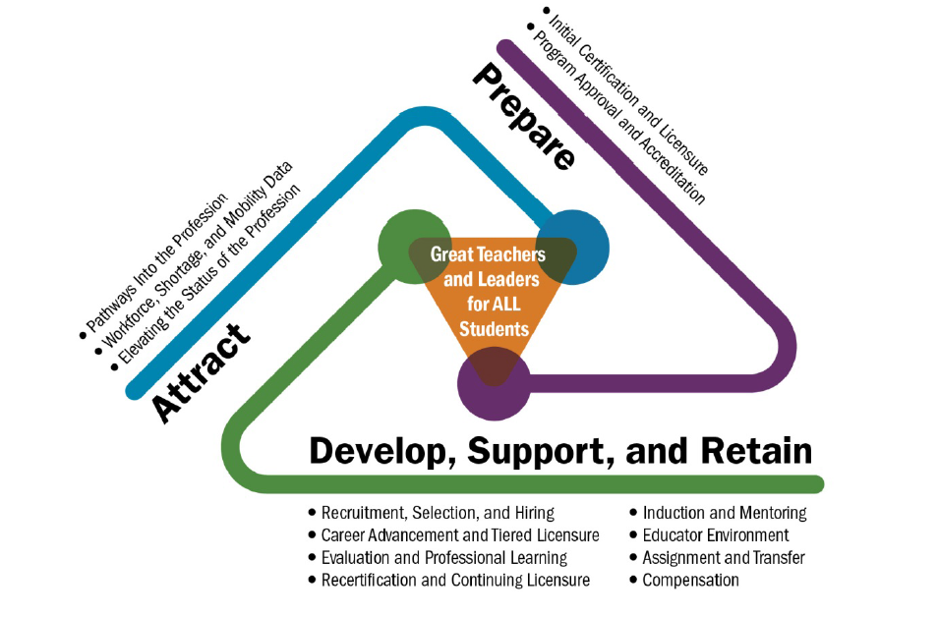

Sample Turnaround Principal Job Description

Turnaround Principal
ABC School District believes that positive change is possible when five core strategies for school improvement are implemented together as a comprehensive package. These strategies include:

- Ensuring every student has an excellent teacher and a school leader committed to their success;
- Setting clear, consistent standards for academic achievement and establishing a school-wide focus on preparing all students for college;
- Increasing instructional time;
- Providing daily, small group tutoring to students using highly qualified and well-trained instructors; and
- Collecting assessment data frequently to monitor each student’s academic progress and tailoring instruction to meet the needs of all learners.

ABC School District is seeking to hire turnaround principals for the 2015–16 school year.

Job Description

Responsibilities:
Instructional Leadership
- Lead the school’s vision, mission, and strategic goals to support college-readiness and academic and socio-emotional success for all students;
- Drive rapid and dramatic instructional improvements by implementing strategies in line with the priority areas identified in the School Turnaround Plan;
- Support and supervise the design of rigorous, standards-based instruction with measurable outcomes;
- Implement an observation and feedback cycle that ensures continuous improvement in teaching and learning;
- Analyze student achievement results to identify areas of need and inform school improvement efforts;
- Develop and implement a professional development plan to address identified areas of need; and
- Develop a collegial environment that supports teacher leadership, collaboration, and growth.

Management and Operations
- Ensure a safe and nurturing environment for students, staff, and families;
- Oversee the recruitment and hiring of diverse, highly-qualified staff;
- Strategically align people, time and money to drive student achievement;
- Apply teacher and staff performance management systems in a way that ensures a culture of continuous improvement, support, and accountability; and
- Comply with all state and federal laws, policies, and collective bargaining agreements.

Family and Community Engagement
- Actively advocate for and engage family and community;
- Strengthen teacher and staff capacity to cultivate and sustain meaningful partnerships with families of diverse backgrounds and with community members that support student achievement and student well-being; and
- Manage partnerships.

Our turnaround leaders:
- Are focused on results and have proven success in increasing student achievement and adult performance;
- Influence and motivate others to reach their potential;
- Are solution-oriented and creative problem solvers with experience in data analysis and creating and managing systems;
- Set high expectations and communicate them to a variety of stakeholders;
- Understand, communicate and effectively interact with people across cultures;
- Continually reflect and seek feedback to improve their practice;
- Have demonstrated perseverance in their career and education;
- Thrive in a fast-paced, change-oriented environment; and
- Possess strong pedagogical skills and are highly effective at coaching other adults.

Qualifications:
- Master's Degree from an accredited institution
- Experience as a school leader required
- 2+ years of teaching experience highly preferred
- Demonstrated experience in English Language Development (ELD) and Sheltered English Immersion (SEI) strategies, strongly preferred
- English/Spanish bilingual, preferred but not required
- Demonstrated experience in building a positive school culture
- State Principal Licensure (by time of appointment)
- Experience in an urban, high-poverty, and/or turnaround school highly preferred.

Application Process:
Interested candidates should apply through our online system. To apply for this position, please visit www.abcschools.org to submit a resume, cover letter, and references.

ABC School District is an equal opportunity employer. M/F/D/V

To cite the content, please use the following statement: These materials have been adapted in whole or in part with permission from the Center on Great Teachers and Leaders, the Center on School Turnaround at WestEd, Public Impact, and the University of Virginia Darden/Curry Partnership for Leaders in Education.

Turnaround Principal Job Description Analysis
Why would a turnaround leader want this job?

Which of these turnaround leader competencies are illustrated in this job description?
Competency | Evidence
Achievement / Focus on Results
- The drive and actions to set challenging goals and reach a high standard of performance despite barriers.
- Taking responsibility to improve outcomes and implement initiatives to accomplish sustainable results.
Impact and Influence
- Acting with purpose of affecting the perceptions, thinking, and actions of others.
Team Leadership / Engaging the Team
- Assuming authoritative leadership of a group for the benefit of the organization.
- Working with a group to leverage their input, develop actionable goals, and implement change in a school.
Conceptual Thinking
- The ability to see patterns and links among seemingly unrelated things.
Analytical Thinking
- The ability to break things down in a logical way and to recognize cause and effect.

To cite the content, please use the following statement: These materials have been adapted in whole or in part with permission from the Center on Great Teachers and Leaders, the Center on School Turnaround at WestEd, Public Impact, and the University of Virginia Darden/Curry Partnership for Leaders in Education.
